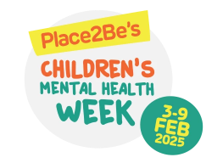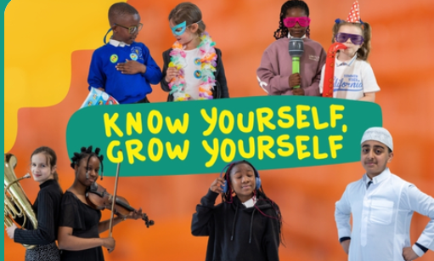
Monday 27th January 2025
Dear parents / carers,
I would like to share with you this term’s Children’s Mental Health and Well-being Week and about the day campaign to be promoted at St. Paul’s Catholic Nursery and Primary School. This will take place on Friday 7th February 2025, with the exploring theme of “Know Yourself, Grow Yourself in partnership with Here4You, supported by The Walt Disney Company and the Inside Out 2 characters” championed by Places2Be.
This themed focus campaign aims to strengthen and to empower and equip children across the UK to share their voice. Teachers will be supporting the children by completing some educational resources to help them understand what makes us all tick, about our likes and dislikes, strengths, fears, hopes and dreams. Our emotions play a key role in telling us just that, and being aware of how to listen to and express ourselves is a major part of building self-awareness. It is through knowing ourselves and speaking with others, that we can build resilience, grow and develop.
The well-being team would like to mark Friday 7th February 2025 as a non-school uniform day by wearing an outfit that expresses themselves, whether it’s their favourite outfit, a splash of colour, a traditional attire that celebrates their culture, or an ensemble that showcases their beloved hobby, we want everyone’s creativity to shine! (We invite a voluntary donation to purchase additional well-being resources for our school children)
For useful parent tips and more information about this campaign please see below and visit this attached link;
Resources and activities for Children's Mental Health Week
For some great Mental Health App’s and useful signposts and support resources on a range of challenges and disorders please visit;
Place2Be: Parenting Smart: Articles
I hope you find this information below useful to support your child/ren at home and how school is continuing to promote and supporting children’s well-being in school.
If you have any questions please feel free to contact your class teacher or myself.
Kind regards,
Netta Costanzo
Deputy Headteacher , SENDco, Inclusion, Mental Health & Well-being Lead

