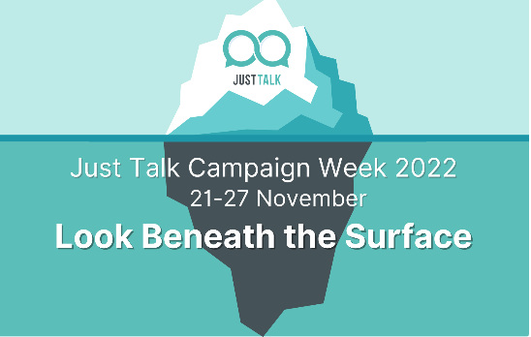

**St Paul’s Catholic Nursery and Primary School is marking**

**Mental Health Awareness Week!**

Friday 11th November 2022

Dear parents,

This year **St Paul’s Catholic Primary School** is marking **Mental Health Awareness Week again**! Monday 21st November 2022 marks the launch of Mental Health Awareness Week, the UK’s national week to raise awareness of mental health.  The week is hosted by the Mental Health Foundation is in its 23rd year and runs from 21-25 November 2022.

This year, Just Talk Week’s theme for 2022 is to **‘Look beneath the surface’,** which encourage us all to be patient with others, as we can’t always know the challenges that someone may be facing.

That’s why, more than ever, it’s so important we don’t jump to conclusions about people or judge them unkindly. It’s important to understand that if you see a friend, family member or someone else you know acting unusually or not their typical self, they may be having a bad day or going through a difficult time.

This Just Talk Week, we’ll be exploring the different ways to help - it’s often as simple as just talking and listening. **"Talking shows strength, not weakness".**

Attached it a link where you will find this year’s resources.

<https://www.justtalkherts.org/news-and-campaigns/just-talk-week-2022.aspx>

**On Thursday 24th November 2021** the Mental Health and Well-being Ambassadors of St Paul’s School have decided to mark the day by wearing their **own clothes** to celebrate ‘feeling good and being unique’. A £1 donation would be greatly appreciated to support our school well-being funds and school development plan.

The day will also include watching educational videos where children will be provided with a range of engaging resources and activities provided by the **Mental Health Foundation. The aim will be;**

* good mental health for all.
* to prevent mental health problems.
* to drive change towards a mentally healthy society for all, and support communities, families and individuals to lead mentally healthy lives with a particular focus on those at greatest risk.
* to recognise the signs and understand strategies that support stress and anxiety

For more information about St Paul’s Mental Health and Well-being Ambassadors, simply visit https://stpauls-herts.secure dbprimary.com/herts/primary/stpauls/site/pages/children/mentalhealthandwellbeing

For more parent information about this year’s Mental Health Awareness Week and guidance please visit;

<https://www.justtalkherts.org/professionals/advice-for-schools-and-professionals.aspx>

For useful publications to support a range of Mental Health experiences please visit; <https://www.mentalhealth.org.uk/publications>

I hope this awareness will be supportive for our children, families and the school community.

Kind regards,

**The Mental Health and Well-being Ambassadors of St Paul’s School**

**&**

**Ms N Costanzo -SENDCo, Inclusion and Mental Health Lead**