Q1.
Here are four shapes on a grid.
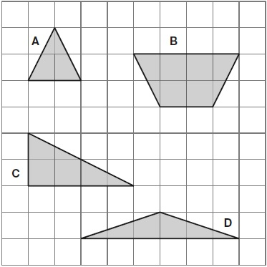
Write the letters of all the shapes that have only two acute angles.
_____________________
1 mark
Q2.
Here is an isosceles triangle inside a rectangle.
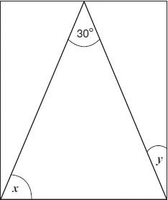
Not to scale
Calculate the sizes of angles x and y.
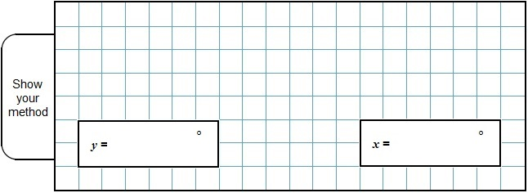
2 marks
Q3.
Stefan stands in the centre of this square.
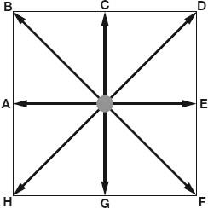
Not actual size
Stefan is facing towards F.
He turns anti-clockwise to face D.
What angle does Stefan turn through?
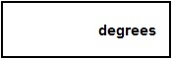
1 mark
Stefan is now facing towards D.
He turns 3 right angles clockwise.
Write the letter he faces after the turn.
________________________
1 mark
Q4.
Here is a sketch of a triangle.
It is not drawn to scale.
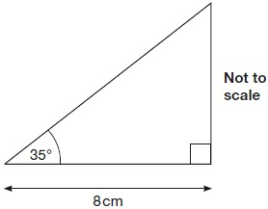
Draw the full-size triangle accurately below.
Use an angle measurer (protractor) and a ruler.
One line has been drawn for you.

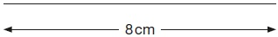
2 marks
Q5.
Kirsty says,
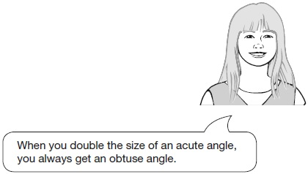
Explain why Kirsty is not correct.
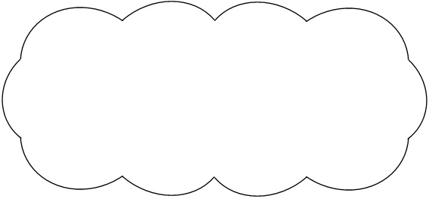
1 mark
Q6.
Two of the angles in a triangle are 70° and 40°
Jack says,
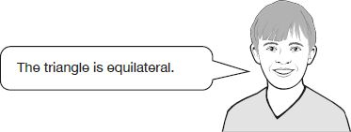
Explain why Jack is not correct.
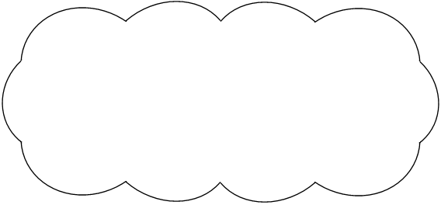
1 mark
Q7.

Layla completes one-and-a-half somersaults in a dive.
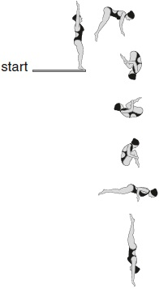
How many degrees does Layla turn through in her dive?
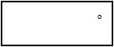
1 mark
Q8.

Circle the pentagon with exactly four acute angles.
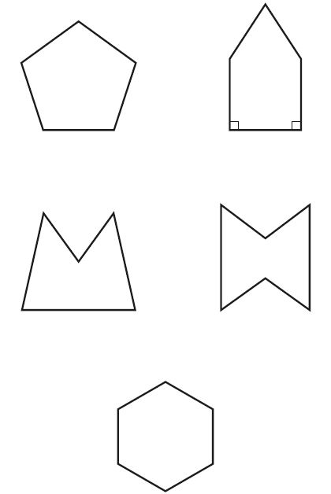
1 mark
Q9.

Calculate the size of angles a and b in this diagram.
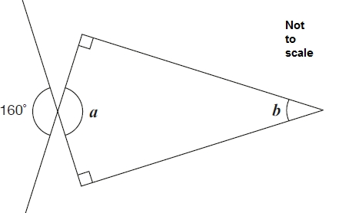
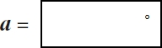
1 mark
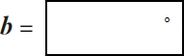
1 mark
Q10.

Here are five angles marked on a grid of squares.
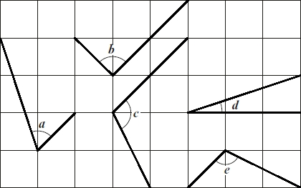
Write the letters of the angles that are obtuse.
________________________
1 mark
Write the letters of the angles that are acute.
________________________
1 mark
Q11.

The diagonals of this quadrilateral cross at right angles.
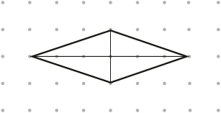
Tick all the quadrilaterals that have diagonals which cross at right angles.
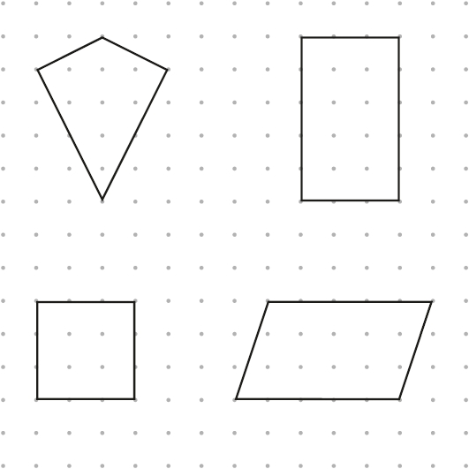
2 marks
Q12.

A shaded isosceles triangle is drawn inside a rectangle.

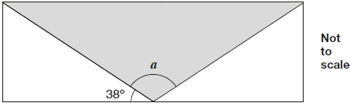
Calculate the size of angle a.

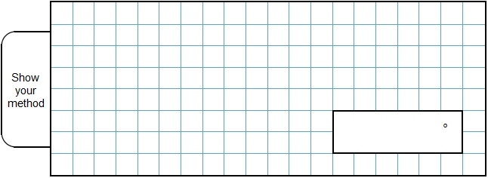
2 marks
Q13.

Here is a rectangle.

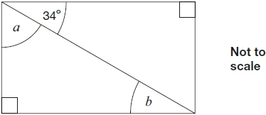
Calculate the size of angles a and b.
Do not measure the angles.
1 mark
1 mark
Q14.

Here are two shapes on a square grid.
For each shape, write how many right angles it has.

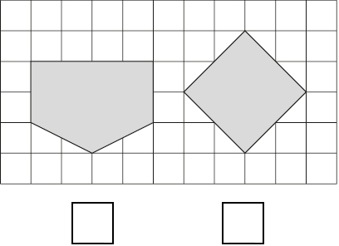
1 mark
Q15.

The diagram shows three identical isosceles triangles.
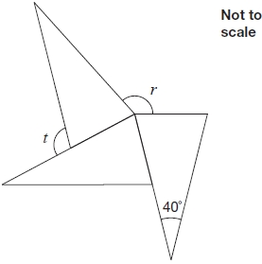
What are the sizes of angles r and t?

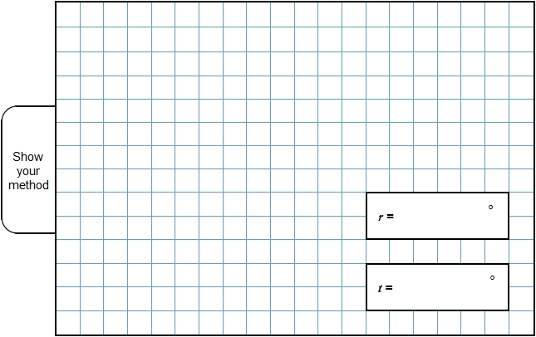
2 marks
Q16.

The diagram shows a shaded triangle inside a rectangle.
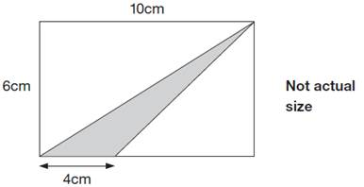
What is the area of the shaded triangle?

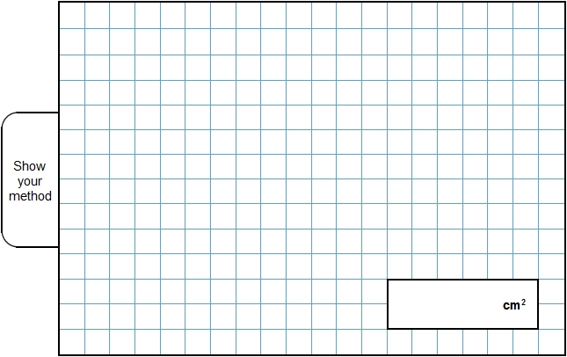
2 marks
Q17.

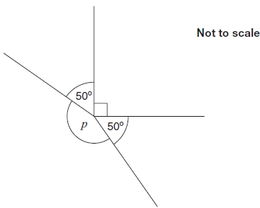
Calculate the size of angle p in the diagram.
Do not use a protractor (angle measurer).

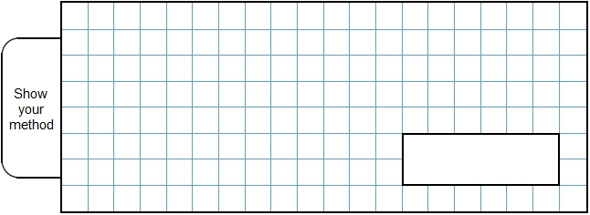
2 marks

Mark schemes
Q1.
Award ONE mark for the correct answer of B, C AND D.
Accept correct letters in any order.
Accept alternative unambiguous positive indication of the correct answer.
[1]
Q2.
Award TWO marks for the correct answer of x = 75 AND y = 15
If the answer is incorrect, award ONE mark for evidence of an appropriate method calculating both angles, e.g.
• 180 − 30 = 150
150 ÷ 2 = 70 (error)
90 − 70
OR
Award ONE mark for either correct x OR y.
Answer need not be obtained for the award of ONE mark.
If there is no evidence of an appropriate method and the values for x AND y are incorrect, accept for ONE mark x + y = 90, unless x is between 65 − 69 (inclusive) AND y is between 21 − 25 (inclusive).
Up to 2m
[2]
Q3.
(a) 90
1
(b) B
Accept alternative unambiguous indication of the correct answer.
1
[2]
Q4.
Award TWO marks for a completed triangle that has all of the following three points:
• an angle in the range 33° to 37° inclusive for the angle marked 35°
• an angle in the range 88° to 92° inclusive for the right angle
• the triangle has been drawn on an 8cm line (either on the given line or a line drawn), provided they have constructed both angles within the tolerance of the line 7.9 cm to 8.1 cm.
If the answer is incorrect, award ONE mark for a completed triangle and TWO of the three points correct.
Accept drawings where any side has been extended past a vertex.
When considering whether the triangle is completed, do not accept:
• a quadrilateral or another shape drawn
OR
• a curved line that is used to complete the shape
OR
• sides not meeting to form a vertex.
Up to 2m
[2]
Q5.
An explanation that includes a correct counter example, e.g.
• When you double 10° it is not obtuse
• 2 × 27° = 54°
• Double 45° is a right angle not obtuse
OR
An explanation that demonstrates where the statement in the question is not correct, e.g.
• If the acute angle is less than 45° then doubling it will be less than 90°, so it won’t be obtuse (more than 90°).
Do not accept vague or incomplete explanations, e.g.
• Sometimes it will be acute
• Some acute angles are half an obtuse angle, but not all
• When you double an acute angle, you get a right angle
Do not accept explanations which include incorrect mathematics or incorrect information that is relevant to the explanation, e.g.
• 20°C × 2 = 40°C
• 20% × 2 = 40%
[1]
Q6.
An explanation showing an understanding:
• that this specific triangle has angles 70, 70 and 40
OR
• of the properties of an equilateral triangle − all angles are equal (60°)
and therefore that this triangle cannot be equilateral, e.g.
• The angles aren’t 60°
• There is not a 60° angle
• It has two different angles (70° and 40°) so it can’t be equilateral
• The angles aren’t the same
• An equilateral triangle has 60° + 60° + 60°
• All the angles are the same in an equilateral triangle
• It’s an isosceles triangle.
(In the context of this question, the term isosceles triangle is treated as not including equilateral triangles as a special type, as the national curriculum does not specify this at key stage 2.)
Do not accept vague or incomplete explanations, e.g.
• The other angle is 70°
• They aren’t (all) the same. (No reference to angles)
• An equilateral triangle has equal angles. (Does not say all.)
Do not accept explanations which include incorrect mathematics or incorrect information that is relevant to the explanation, e.g.
• 40 + 70 = 110 + 70 = 180
[1]
Q7.

540
[1]
Q8.

The correct shape circled as shown:
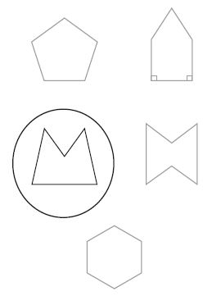
Accept alternative unambiguous positive indications, e.g. shape ticked.
[1]
Q9.

(a) 160
1
(b) 20
If the answers to a and b are incorrect, award ONE mark if
a + b = 180° unless b is between 33° and 37° inclusive, or 90°.
1
[2]
Q10.

(a) c AND e
Letters may be given in either order.
1
(b) a AND d
Letters may be given in either order.
1
[2]
Q11.

Award TWO marks for both kite AND square ticked as shown.
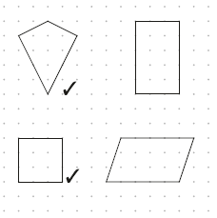
If the answer is incorrect, award ONE mark for:
• kite AND square and not more than one incorrect shape ticked.
OR
• one correct shape only ticked.
Accept alternative unambiguous positive indications, e.g. shapes circled.
Up to 2m
[2]
Q12.
Award TWO marks for the correct answer of 104°.
If the answer is incorrect, award ONE mark for evidence of an appropriate method, e.g:
• 180 − 38 − 38 = a
Answer need not be obtained for the award of ONE mark.
Up to 2
[2]
Q13.
(a) 56
1
(b) 34
If the answers to (a) and (b) are incorrect, award ONE mark if their (a) plus their (b) = 90°, provided that (b) is not 45°, 30° or 60°.
1
[2]
Q14.
2 AND 4
Accept alternative unambiguous indications, eg right angles marked on diagrams.
[1]
Q15.
r = 150 and t = 110
Values must be unambiguously associated with the correct letter for the award of 2m or 1m
2
or
r or t correct
OR
Shows or implies a complete, correct method for both angles, eg:
• 40 + 50 + 50 = 180 (error)
360 − 50 − 50 − 50 = 210
180 − 50 = 130
! Answers for r and t transposed
If r is 110 and t is 150, then award 1m
! Follow-through from incorrect base angle seen on the diagram
Award 1m if both r and t correctly follow through from an incorrect angle seen at base of an isosceles triangle, eg:
•
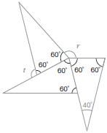
r = 360 − 180 = 180
t = 180 − 60 = 120
1
[2]

Q16.
12
2
or
Shows or implies a complete correct method, eg:
• 4 × 6 ÷ 2 = 13 (error)
• 60 − (10 × 6 ÷ 2) – (6 × 6 ÷ 2)
• 60 − 48
1
[2]

Q17.
Award TWO marks for correct answer of 170°
Up to 2
If the answer is incorrect, award ONE mark for
evidence of an appropriate method, eg:
• 50 + 50 + 90 = 190
360 – 190
OR
• 360 – 50 – 50 – 90
Answer need not be obtained for the award
of ONE mark.
Up to 2
[2]

