Q1.
This table shows the cost of fruit at a school cafeteria.

Fruit | Cost for one
banana | 12p
plum | 23p
apple | 32p
pear | 38p
Amir buys two pieces of fruit.
He pays with a £2 coin.
He gets £1.50 change.
Tick the two pieces of fruit that Amir buys.

 | Tick two.
banana | 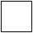
plum
apple
pear
1 mark
Q2.
Chen buys these four items.
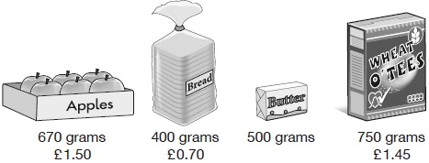
Chen pays for the four items with a £10 note. The price of the butter is not shown.
She receives £3.85 change.
What is the price of the butter?
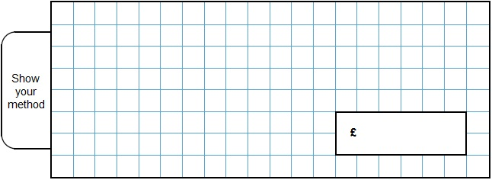
2 marks
Q3.
Jack buys milk and orange juice from a shop.
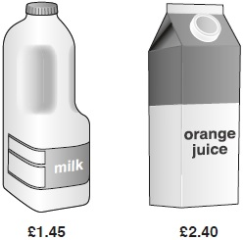
He pays with a £5 note.
How much change does Jack get?
2 marks
Q4.
These are the prices of some vegetables in a shop.

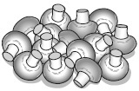 |  | 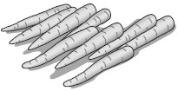
Mushrooms  £3.20 for 1 kg |  | Carrots  60p for 1 kg
Layla buys 500 grams of mushrooms and kg of carrots.
She pays with a £5 note.
How much change does Layla get?
2 marks
Q5.
A shop has an offer.
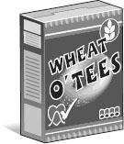

Buy one box for £1.90
Get the second box half price.
Ali buys two boxes of cereal.
How much must he pay altogether?
2 marks
Q6.
Olivia buys a banana, an apple and a bag of nuts.

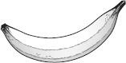 | 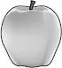 | 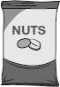
30p | 45p | 60p
She pays with three 50p coins.
What is her change?
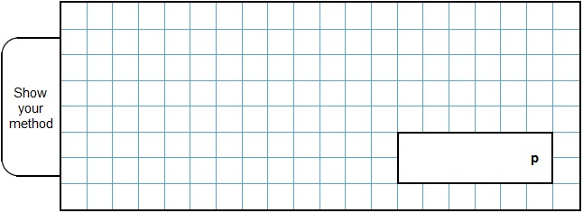
2 marks
Q7.
Adam buys 4 pens and a ruler and pays £4.75 altogether.
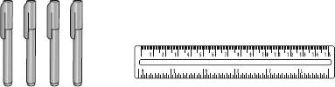
Jack buys 2 pens and pays £1.98 altogether.
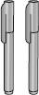
How much does a ruler cost?
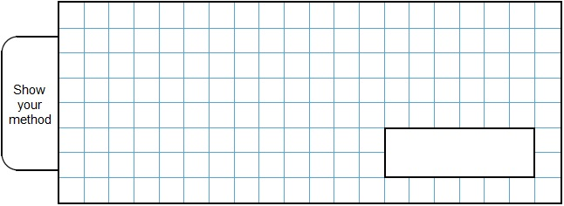
2 marks
Q8.
Jack hires a hall for a party.
This formula is used to work out the total cost.

Total cost = £15 booking fee + £12.50 per hour
What is the total cost of hiring the hall from 6 pm until 11 pm?
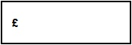
1 mark
Q9.

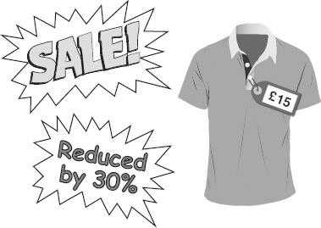
The full price of a T-shirt is £15
The price is reduced by 30%.
What is the reduced price?
2 marks
Q10.
The original price of this car is £8,999
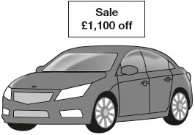
What is the sale price of the car?
1 mark
Q11.
Amina is shopping.
She says,
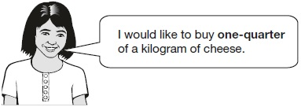
Write one-quarter on the scales as a decimal.
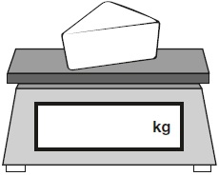
1 mark
The cheese costs £1.35
Amina pays with a £2 coin.
How much change should Amina get?
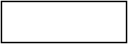
1 mark
Q12.
John buys one toy car and one pack of stickers.
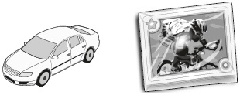
£1.49 £1.64
He pays with a £10 note.
How much change does John get?
2 marks
Q13.
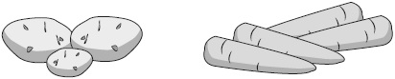
potatoes carrots
£1.50 per kg £1.80 per kg
Jack buys kg of potatoes and kg of carrots.
How much change does he get from £5?
2 marks
Q14.

The children at Farmfield School are collecting money for charity.
Their target is to collect £360
So far they have collected £57.73
How much more money do they need to reach their target?
1 mark
Q15.

Amina posts three large letters.
The postage costs the same for each letter.
She pays with a £ 20 note.
Her change is £14.96
What is the cost of posting one letter?
2 marks
Q16.

3 pineapples cost the same as 2 mangoes.  One mango costs £1.35 | 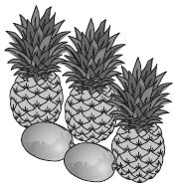
How much does one pineapple cost?
2 marks
Q17.

6 pencils cost £1.68 | 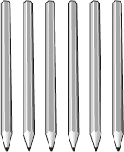
3 pencils and 1 rubber cost £1.09 | 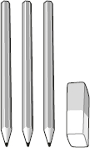
What is the cost of 1 rubber?
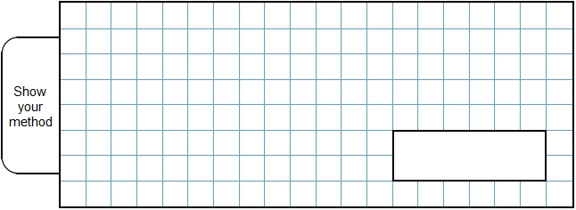
2 marks
Q18.

One gram of gold costs £32.94
What is the cost of half a kilogram of gold?

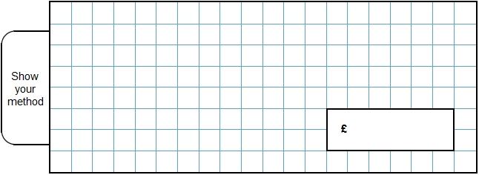
2 marks
Q19.

Large pizzas cost £8.50 each.
Small pizzas cost £6.75 each.
Five children together buy one large pizza and three small pizzas.
They share the cost equally.
How much does each child pay?

2 marks
Q20.

Lara had some money.
She spent £1.25 on a drink.
She spent £1.60 on a sandwich.
She has three-quarters of her money left.
How much money did Lara have to start with?
2 marks
Q21.

Olivia buys three packets of nuts.
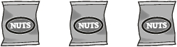
She pays with a £2 coin.
This is her change.
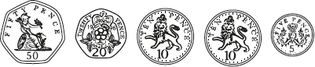
What is the cost of one packet of nuts?
2 marks
Q22.

A bag of 5 lemons costs £1
A bag of 4 oranges costs £1.80
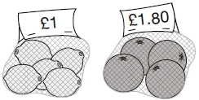
How much more does one orange cost than one lemon?

2 marks
Q23.

Liam has five coins.
Three of the coins add up to 30p.
Three of the coins add up to 40p.
All five coins add up to £1
What are the coins that Liam has?

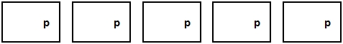
1 mark
Q24.

A shop sells pairs of socks.
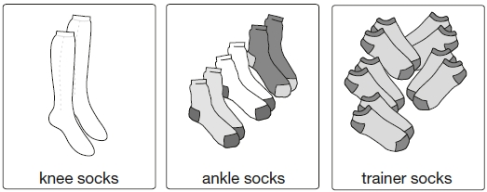
1 pair for £5.45 3 pairs for £7.50 5 pairs for £8. 50

Kirsty buys 1 pair of knee socks and 3 pairs of ankle socks.
She pays with a £20 note.
How much change does she get?

2 marks
Amy spends £25.50 on trainer socks.
How many pairs of trainer socks does she get?
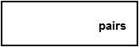
1 mark
Q25.

A shop sells fruit.
Chen buys 2 apples and 3 bananas.  He pays £2.35 | 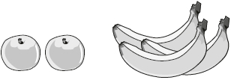

Megan buys 2 apples and 1 banana.  She pays £1.25 | 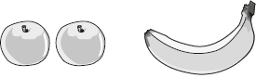

How much does one banana cost?

2 marks
Q26.

Chen and Megan each buy a sandwich.
Chen gets 5p change from £2
Megan gets £2.25 change from £5
How much more does Megan pay than Chen?

2 marks
Q27.

Liam buys two apples. | 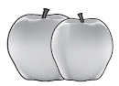
He pays with a £1 coin and gets 64p change.
How much does one apple cost?
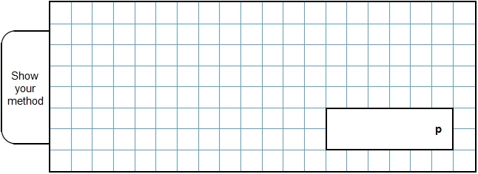
2 marks
Q28.
(a) 1 kilogram of grapes costs £5.80
Megan buys 700 grams of grapes.
How much does she pay?
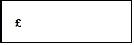
1 mark
(b) 1 kilogram of cheese costs £13.50
Megan buys a piece of cheese costing £2.49

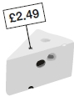
What is the mass of the cheese to the nearest 100 grams?

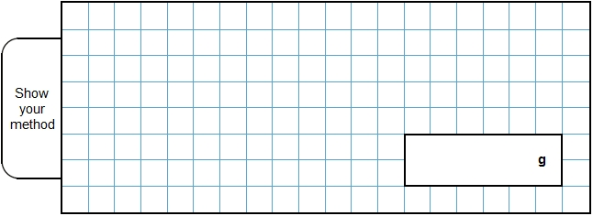
2 marks
Q29.

Mina and Seb share these coins so that they each have the same amount of money.
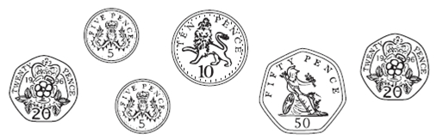
Mina chooses her coins first.
Seb takes the rest of the coins.
Which coins could Mina choose?
_________________________
1 mark
Q30.

The table below shows five journeys a taxi driver made one day.

journey number | start time | number of passengers | distance | cost
1 | 9:15 am | 2 | 8 km | £7.50
2 | 9:40 am | 1 | 12 km | £9.90
3 | 10:30 am | 3 | 7 km | £7.60
4 | 10:50 am | 1 | 21 km | £15.50
5 | 12:10 pm | 4 | 15 km | £12.00
On journey number 5, the passengers shared the cost equally.
How much did each passenger pay?
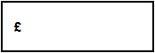
1 mark
How many passengers made journeys of more than 10 km?
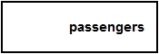
1 mark
The 12 km journey took 40 minutes.
What time did the taxi finish its journey?
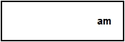
1 mark
Q31.

These are the prices of cheese in a shop.
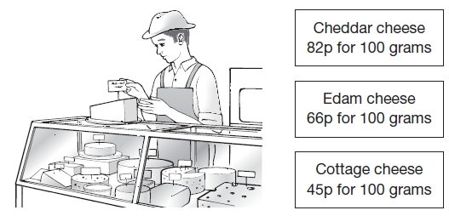
Mina buys 200 g of Cheddar cheese and 150 g of Edam cheese.
How much does she pay altogether?

2 marks
Seb buys some cottage cheese for £1.35.
How many grams of cottage cheese does he get?
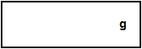
1 mark
Q32.

Liam, Sarah and Amy buy lunch at a salad bar.

salad bar
Salads |  | Desserts
cheese  egg  tuna | £1.20  90p  £1.60 | banana  apple pie  yogurt | 25p  50p  35p
Liam has £2.50 to spend.
He buys a tuna salad and an apple pie.
How much money has he got left?
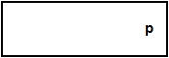
1 mark
Sarah buys a cheese salad and a yogurt.
Amy buys an egg salad.
How much more does Sarah pay than Amy?

2 marks
Q33.

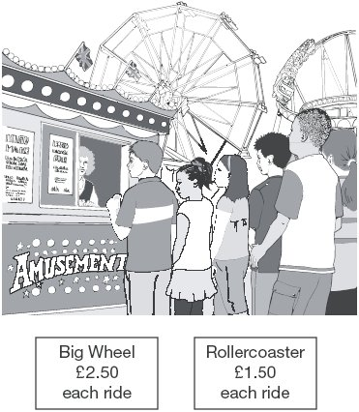
Liam spends £14 altogether on the Big Wheel and the Rollercoaster.
He goes on the Big Wheel twice.
How many times does he go on the Rollercoaster?

2 marks
Q34.

Write these prices in order, starting with the smallest.

72p |  | £2.70 |  | £0.27 |  | £7.20 |  | £2.07
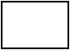
smallest
1 mark
Q35.

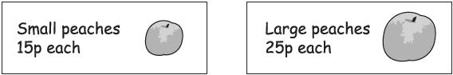
Emily has £5 to spend on peaches.
She decides to buy only small peaches or only large peaches.
How many more small peaches than large peaches can she buy for £5?

2 marks
Q36.

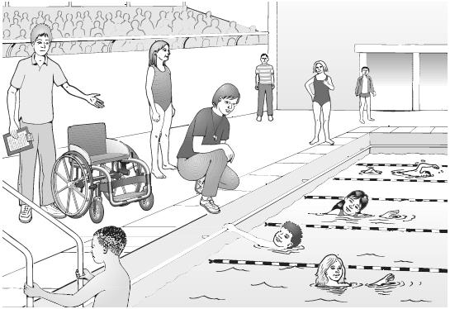
Emily, Ben and Nisha take part in a sponsored swim to collect money for charity.
Emily collects £2.75 more than Nisha.
Ben collects £15
Nisha collects £7 less than Ben.
Altogether how much money do the three children collect?

2 marks
Q37.

Here are three bags in a shop

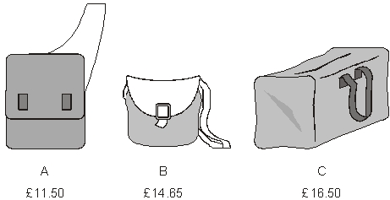
How much does bag B cost to the nearest pound?
1 mark
Jamie buys bag A and bag C.
How much change does he get from £40?

2 marks
Q38.

A shop sells candles.

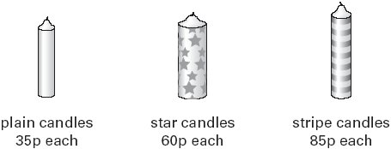
Sapna buys 4 star candles and 2 stripe candles.
How much does she pay altogether?

2 marks
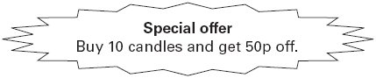
Josh buys 10 plain candles in the special offer.
How much does he pay for the 10 candles?
1 mark
Q39.

Calculate of £15
1 mark
Q40.

Forest School sells badges for charity.

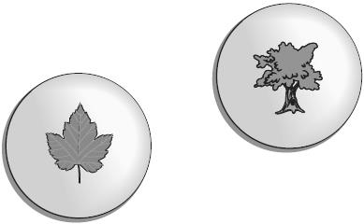
For each badge sold, £1.20 is given to a charity.
How much does the charity get when 12 badges are sold?
1 mark
If the charity got £24, how many badges were sold?
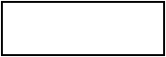
1 mark
Q41.

These are the prices in a shoe shop.
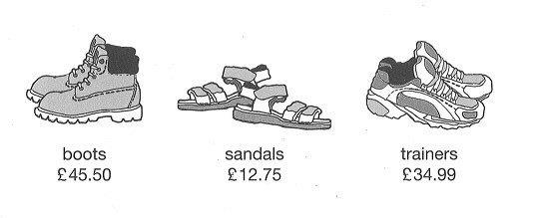
How much more do the boots cost than the trainers?
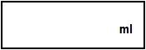
1 mark
Rosie buys a pair of trainers and a pair of sandals.
How much change she gets from £50?

2 marks

Mark schemes
Q1.
Award ONE mark for two boxes ticked correctly, as shown:

banana | 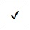
plum
apple
pear
Accept alternative unambiguous positive indication of the correct answer.
[1]
Q2.
Award TWO marks for the correct answer of (£)2.50
If the answer is incorrect, award ONE mark for evidence of an appropriate complete method which contains no more than ONE arithmetic error, e.g.
• £1.50 + £0.70 + £1.45 = £3.65
£10.00 − £3.65 = £6.15 (error)
£6.15 − £3.85 = £2.30
OR
• £1.50 + £0.70 + £1.45 + £3.85 = £7.50
£10.00 − £7.50 = £3.50 (error)
If no final answer is given, all calculations within an appropriate method must be evaluated correctly for the award of ONE mark, e.g.
• £1.50 + £0.70 + £1.45 = £3.65
£10.00 − £3.65 = £6.35
£6.35 − £3.85
Accept for ONE mark an answer of £250, £250p, £2,50 or £2.5 as evidence of an appropriate method.
Refer to section 2.1 on pages 8 and 9 for additional guidance on marking answers involving money (see Resource).
Misreads of £3.85 as £3.65 OR miscopies of £3.65 as £3.85 are not allowed.
Up to 2m
[2]
Q3.
Award TWO marks for the correct answer of (£)1.15
If the answer is incorrect, award ONE mark for evidence of an appropriate method, e.g.
• £1.45 + £2.40 = £3.85
£5.00 − £3.85
OR
• £5.00 − £1.45 = £3.55
£3.55 − £2.40
Answer need not be obtained for the award of ONE mark.
Accept for ONE mark an answer of £115, £115p or £1,15 as evidence of an appropriate method.
Refer to section 2.1 on pages 8 and 9 for additional guidance on marking answers involving money (see Resource).
Up to 2m
[2]
Q4.
Award TWO marks for the correct answer of (£)2.65
If the answer is incorrect, award ONE mark for evidence of a complete method which contains no more than one arithmetic error, e.g.
• £3.20 ÷ 2 = £1.60
of 60p = 15p
60p + 15p = 75p
£1.60 + 75p = £2.25 (error)
£5 − £2.25 = £2.75
OR
• sight of (£)2.35 OR 235 (p) (as evidence of the total cost of mushrooms and carrots).
Misreads are not allowed.
Accept for ONE mark an answer of £265, £265p or £2,65 as evidence of an appropriate method.
Refer to section 2.1 on pages 8 and 9 for additional guidance on marking answers involving money. (see Resource)
Up to 2m
[2]
Q5.
Award TWO marks for the correct answer of (£)2.85
If the answer is incorrect, award ONE mark for evidence of an appropriate method, e.g.
• 190 ÷ 2 = 85 (error)
190 + 85
OR
• 1.90 × 1.5
Answer need not be obtained for the award of ONE mark.
Accept for ONE mark an answer of (£)285 OR £285p as evidence of an appropriate method.
Refer to section 2.1 on pages 8 and 9 for additional guidance on marking answers involving money (see Resource).
Up to 2m
[2]
Q6.
Award TWO marks for the correct answer of 15(p)
If the answer is incorrect, award ONE mark for evidence of an appropriate method, e.g.
• 30p + 45p + 60p = 135p
50p × 3 − 135p
OR
• 50 − 30 = 20
50 − 45 = 5
20 + 5 + 50 = 75
75 − 60
OR
• 150 − 45 = 95 (error)
95 − 60 = 35
35 − 30
Answer need not be obtained for the award of ONE mark.
Accept for ONE mark an answer of 0.15(p) OR £15(p) as evidence of an appropriate method.
Refer to section 2.1 on pages 8 and 9 for additional guidance on marking answers involving money (see Resource).
Up to 2m
[2]
Q7.
Award TWO marks for the correct answer of 79(p) OR (£)0.79
If the answer is incorrect, award ONE mark for an appropriate method, e.g.
• £4.75 − £1.98 = £2.77
£2.77 − £1.98
OR
• 198 × 2 = 397p (error)
£4.75 − 397p
OR
• £2 × 2 = £4
£4.75 − £4 = 75p
75p + 4p
Answer need not be obtained for the award of ONE mark.
Accept for ONE mark an answer of 0.79p OR £79(p) as evidence of a correct method.
Refer to section 2.1 on pages 8 and 9 for additional guidance on marking answers involving money (see Resource).
Up to 2m
[2]
Q8.
£77.50
Refer to section 2.1 on pages 8 and 9 for additional guidance on marking answers involving money (see Resource).
[1]
Q9.
Award TWO marks for the correct answer of (£)10.50
If the answer is incorrect, award ONE mark for evidence of an appropriate method, e.g.
• 70 × 15 ÷ 100
OR
• 10 × 15 ÷ 100 = £1.50
3 × £1.50 = £4.50
£15 − £4.50
OR
Award ONE mark for sight of (£)4.50
Answer need not be obtained for the award of ONE mark.
Award ONE mark for a final answer of (£)10.5 OR (£)105 OR (£)1050 as evidence of an appropriate method.
Refer to section 2.1 on pages 8 and 9 for additional guidance on marking answers involving money (see Resource).
Up to 2m
[2]
Q10.
£7,899
[1]
Q11.
(a) 0.25
Do not accept or any other fraction
Refer to section 2.3 on page 10 for additional guidance on marking answers involving measures (see Resource).
1
(b) 65(p) OR (£)0.65
Refer to section 2.1 on pages 8 and 9 for additional guidance on marking answers involving money (see Resource).
1
[2]
Q12.
Award TWO marks for the correct answer of £6.87
If the answer is incorrect, award ONE mark for evidence of an appropriate method, e.g.
• £1.49 + £1.64 = £3.13
• £10 − £3.13 =
OR
• £10 − £1.49 = £8.51
• £8.51 − £1.64 =
OR
• £10 − 164p − 149p =
Answer need not be obtained for the award of ONE mark.
Accept for ONE mark an answer of £687 OR £687p as evidence of an appropriate method.
Refer to section 2.1 on pages 8 and 9 for additional guidance on marking answers involving money (see Resource).
Up to 2 marks
[2]
Q13.
Award TWO marks for the correct answer of £1.85
If the answer is incorrect, award ONE mark for evidence of an appropriate method, e.g.
• × £1.50 = £2.25
of £1.80 = 70p (error)
£2.25 + 70p = £2.95
£5 − £2.95 =
OR
• £1.50 + 75 = £2.25
£2.25 + 90 = 415p (error)
£5.00 − 415p =
OR
• sight of £3.15 OR 315p as evidence of evaluating the correct cost of the potatoes and carrots.
Do not accept misreads for this question.
Answer need not be obtained for the award of ONE mark.
Accept for ONE mark an answer of £185 or £185p as evidence of an appropriate method.
Refer to section 2.1 on pages 8 and 9 for additional guidance on marking answers involving money (see Resource).
Up to 2 marks
[2]
Q14.

£ 302.27
[1]
Q15.

Award TWO marks for the correct answer of £1.68
If the answer is incorrect, award ONE mark for evidence of an appropriate method, e.g.
• 20 − 14.96 = 5.04
5.04 ÷ 3
Accept for ONE mark an answer of £168 OR £168p as evidence of an appropriate method.
Answer need not be obtained for the award of ONE mark.
Up to 2m
[2]
Q16.

Award TWO marks for the correct answer of £0.90
If the answer is incorrect, award ONE mark for evidence of an appropriate method, e.g.
• £1.35 × 2 = £2.70
£2.70 ÷ 3
Accept for ONE mark an answer of £90p OR £0.9 as evidence of an appropriate method.
Answer need not be obtained for the award of ONE mark.
Up to 2m
[2]
Q17.

Award TWO marks for the correct answer of 25p.
If the answer is incorrect, award ONE mark for evidence of an appropriate method, e.g.
• 168 ÷ 2 = 84
109 – 84
OR
• 168 ÷ 6 = 28
3 × 28 = 84
109 – 84
Accept for TWO marks, an answer given in the acceptable notation.
Answer need not be obtained for the award of ONE mark.
Accept for ONE mark an answer of 0.25p OR £25p OR £25 as evidence of an appropriate method.
Up to 2m
[2]
Q18.
Award TWO marks for the correct answer of £16,470
If the answer is incorrect, award ONE mark for evidence of an appropriate method, e.g:
• £32.94 × 1000 = £32,940
£32,940 ÷ 2
OR
• £32.94 × 500
= £3294 × 5
Answer need not be obtained for the award of ONE mark.
Up to 2
[2]
Q19.
Award TWO marks for the correct answer of £5.75
If the answer is incorrect, award ONE mark for evidence of an appropriate method, e.g:
• £6.75 × 3 = £20.25
£20.25 + £8.50 = £28.75
£28.75 ÷ 5
Answer need not be obtained for the award of ONE mark.
Up to 2
[2]
Q20.

Award TWO marks for the correct answer of £11.40.
If the answer is incorrect, award ONE mark for evidence of an appropriate method, e.g.
• £1.25 + £1.60 = £2.85
£2.85 × 4
Accept for ONE mark an answer of £1,140 OR £1,140p OR £11.4 as evidence of an appropriate method.
Answer need not be obtained for the award of ONE mark.
Up to 2m
[2]
Q21.

Award TWO marks for the correct answer of 35p OR £0.35.
If the answer is incorrect, award ONE mark for evidence of an appropriate method, e.g.
• 50p + 20p + 10p + 10p + 5p = 95p
£2.00 − 95p = £1.05
£1.05 ÷ 3
Accept for ONE mark an answer of £35 OR £35p OR 0.35p as evidence of an appropriate method.
Answer need not be obtained for the award of ONE mark.
Up to 2m
[2]
Q22.
Award TWO marks for the correct answer of 25p or £0.25.
If the answer is incorrect, award ONE mark for evidence of an appropriate method, e.g:
• Lemons £1 ÷ 5 = 20p each
Oranges £1.80 ÷ 4 = 45p each
45p – 20p
Answer need not be obtained for the award of ONE mark.
Up to 2
[2]
Q23.
50p 20p 10p 10p 10p
Coins may be given in any order.
U1
[1]
Q24.
(a) Award TWO marks for the correct answer of £7.05
If the answer is incorrect, award ONE mark for evidence of appropriate working, eg:
■ £20 - £5.45 - £7.50 = wrong answer
OR
■ £5.45 + £7.50 = £12.95
£20 - £12.95 = wrong answer
Accept for ONE mark £705 OR £705p as evidence of appropriate working.
Working must be carried through to reach an answer for the award of ONE mark.
Up to 2
(b) 15
1
[3]
Q25.
Award TWO marks for the correct answer of 55p OR £0.55
If the answer is incorrect, award ONE mark for evidence of appropriate working, eg
■ £2.35 – £1.25 = £1.10
£1.10 ÷ 2 = wrong answer
Accept for ONE mark £55 OR £55p OR 0.55p as evidence of appropriate working.
Working must be carried through to reach an answer for the award of ONE mark.
Up to 2
U1
[2]
Q26.
Award TWO marks for the correct answer of 80p OR £0.80
If the answer is incorrect, award ONE mark for evidence of
appropriate working, eg:
■ £2.00 − £0.05 = £1.95
£5.00 − £2.25 = £2.75
£2.75 − £1.95 = wrong answer
Accept for ONE mark £80 OR £80p OR 0.80p as evidence of appropriate working.
Working must be carried through to reach an answer for the award of ONE mark.
Up to 2m
[2]

Q27.
Award TWO marks for the correct answer of 18
If the answer is incorrect, award ONE mark for evidence of appropriate working, eg:
■ 100 − 64 = 36
36 ÷ 2 = wrong answer
Accept for ONE mark 0.18 as evidence of appropriate working.
Working must be carried through to reach an answer for the award of ONE mark.
Up to 2
[2]

Q28.
(a) £4.06
! Money
See guidance
1
(b) 200
! Measures
See guidance
2
or
Gives an answer of 180 or 184 or 184.4(…)
OR
Shows or implies a complete correct method, eg:
• 1000 × 2.49 ÷ 13.50
• £13.50 ÷ £2.49 = 5.42
1000 ÷ 5.42
• 1350 ÷ 1000 = 1.35
249 ÷ 1.35
• £1.35 = 100
£2.70 = 200
! Inconsistent units
Within an otherwise correct method, condone
eg, for 1 mark accept:
• (£)13.50 ÷ 1000 = 1.35(p)
(£)2.49 ÷ 1.35(p)
• (£)13.50 ÷ 1000 = (£)0.0135
249(p) ÷ (£)0.0135
1
[3]
Q29.
50p AND 5p
OR
20p AND 20p AND 10p AND 5p
Coins may be given in any order.
Accept alternative unambiguous indications, eg coins ticked, crossed or underlined.
Accept answers with missing units, eg 50 AND 5
U1
[1]
Q30.
(a) £3.00
1
(b) 6
1
(c) 10:20 am
The answer is a specific time.
1
[3]
Q31.
(a) Award TWO marks for the correct answer of £2.63
If the answer is incorrect, award ONE mark for evidence of appropriate
working, eg
82p × 2 = 164p
66p + 33p = 99p
164p + 99p = wrong answer
Accept for ONE mark £263 OR £263p as evidence of
appropriate working.
Working must be carried through to reach an answer
for the award of ONE mark.
Up to 2
(b) 300
1
[3]
Q32.
(a) 40p
1
(b) Award TWO marks for the correct answer of 65p OR £0.65
If the answer is incorrect, award ONE mark for evidence of
appropriate working, eg
120 + 35 = 155
155 – 90 = wrong answer
Accept for ONE mark £65 OR £65p OR 0.65p as evidence of appropriate working.
Working must be carried through to reach an answer for the award of ONE mark.
Up to 2
[3]
Q33.
Award TWO marks for the correct answer of 6
Accept for ONE mark an answer of £6 as evidence of appropriate working.
If the answer is incorrect, award ONE mark for evidence of appropriate working, eg
2.50 × 2 = 5
14 – 5 = 9
9 ÷ 1.50 = wrong answer
Working must be carried through to reach an answer for the award of ONE mark.
OR
14 – 2.50 – 2.50 = 9
1.50 × wrong number = 9
Up to 2
[2]
Q34.
Prices in order, as shown:
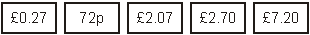
Accept use of equivalent units, eg 27p.
Accept answers with missing or incorrect units.
[1]
Q35.
Award TWO marks for the correct answer of 13
If the answer is incorrect, award ONE mark for evidence of appropriate
method, eg
500 ÷ 15 = 33
500 ÷ 25 = 20
33 – 20
Award ONE mark for an answer of 13 OR 13. ˙3 OR 13.3 OR 13.33, etc.
Award ONE mark for sight of 20 AND 33 with no evidence of an incorrect method.
Answer need not be obtained for the award of ONE mark.
Up to 2
[2]
Q36.
Award TWO marks for the correct answer of £33.75
If the answer is incorrect, award ONE mark for evidence of appropriate
method, eg:
• Ben: £15
Nisha: £15 – £7 = £8
Emily: £8 + £2.75 = £10.75
£15 + £8 + £10.75
OR
• 15 + (15 – 7) + (15 – 7 + 2.75)
Accept for ONE mark £3375 OR £3375p as evidence of appropriate method.
Answer need not be obtained for the award of ONE mark.
Up to 2
[2]
Q37.
(a) £15
1
(b) Award TWO marks for the correct answer of £12
If the answer is incorrect, award ONE mark for evidence
of appropriate working, eg
11.50 + 16.50 = 28
40 – 28 = wrong answer
Accept: for ONE mark £1200 OR £1200p as evidence of appropriate working.
Working must be carried through to reach an answer for the award of ONE mark.
Up to 2
[3]

Q38.
(a) Award TWO marks for the correct answer of £4.10 OR 410p
If the answer is incorrect, award ONE mark for evidence of
appropriate working, eg
4 × 60 = 240
2 × 85 = 170
240 + 170 = wrong answer
Accept for ONE mark £410 OR £410p as evidence of appropriate working.
Calculation must be performed for the award of ONE mark.
Up to 2
(b) £3.00
1
[3]
Q39.
£11.25
[1]
Q40.
(a) £14.40
Do not accept £14.4
1
(b) 20
Do not accept £20
1
[2]
Q41.
(a) £10.51
1
(b) Award TWO marks for the correct answer of £2.26
If the answer is incorrect, award ONE mark for evidence of
appropriate method, eg
34.99 + 12.75 = 47.74
50 – 47.74
OR
50 – 12.75 – 34.99
Accept for ONE mark £226 OR £226p as evidence of appropriate method.
Answer need not be obtained for the award of ONE mark.
Up to 2
[3]

