Q1.
The numbers in this sequence increase by the same amount each time.
Write the missing numbers.
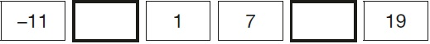
1 mark
Q2.
Write the missing numbers in the table.

Number of weeks | Number of days
1 | 7
2 | 14
4 | 28
6
10
 | 105
1 mark
Q3.
Here is a number sequence.

75 50 25 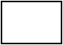
Write the next two numbers in the sequence.
1 mark
Q4.
Write the next two numbers in this sequence.

1,780 1,880 1,980
1 mark
Q5.
The numbers in this sequence increase by 45 each time.
Write the missing numbers.

2 marks
Q6.
Here is part of a number square.
The other part of the square has been torn off.
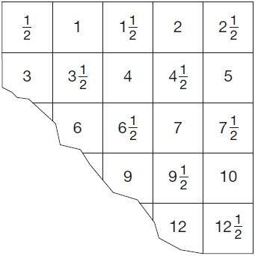
What number was in the bottom-left corner of the number square?

1 mark
Q7.
In this sequence, the rule to get the next number is

Multiply by 2, and then add 3
Write the missing numbers.

2 marks
Q8.
The list below shows the years in which the Cricket World Cup was held since 1992:
1992, 1996, 1999, 2003, 2007, 2011, 2015
Adam says,
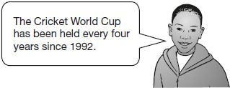
Adam is not correct.
Explain how you know.

1 mark
Q9.
The numbers in this sequence decrease by the same amount each time.
303,604 302,604 301,604 300,604 …
What is the next number in the sequence?
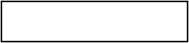
1 mark
Q10.
The numbers in this sequence increase by the same amount each time.
Write the missing numbers.

2 marks
Q11.

Here is a doubling sequence.
Write the three missing numbers.

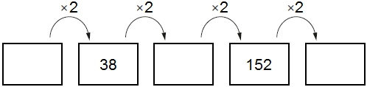
2 marks
Q12.

Here is part of a number line.
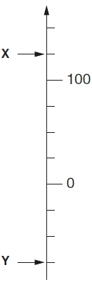

What is the value of X?
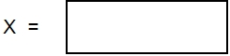
1 mark
What is the value of Y?
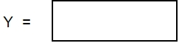
1 mark
Q13.

The numbers in this sequence increase by 30 each time.
20 50 80 110 ...
The sequence continues in the same way.
Which number in the sequence will be closest to 300?

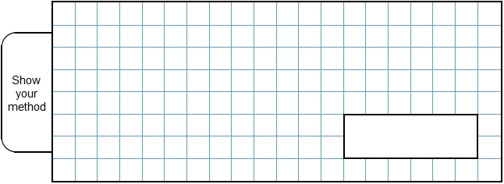
2 marks
Q14.

Jon makes a sequence of numbers.
His rule is to add the same amount each time.
Write in the missing numbers.

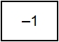 | 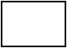 |  |  | 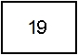
1 mark
Q15.

The numbers in this sequence increase by 10 each time.
3 13 23 …
The sequence continues in the same way.
Write two numbers from the sequence that add to make a total of 96
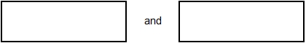
1 mark
Explain why it is not possible to find three numbers from the sequence that add to make a total of 96


1 mark
Q16.

The numbers in this sequence increase by the same amount each time.
Write the two missing numbers.

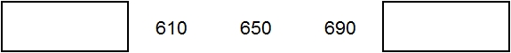
2 marks
Q17.

The numbers in this sequence increase by equal amounts each time.
Write in the three missing numbers.

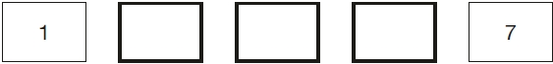
2 marks
Q18.

Here is part of a number sequence.
The numbers in the sequence increase by 25 each time.
50 75 100 125 …
Circle all of the numbers below that will appear in the sequence.
255 650 735 900 995
1 mark
Q19.

The rule to get each number in a sequence is
Here is part of the sequence.
Write the two missing numbers.

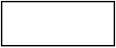 | 40 | 30 | 35 | 32.5 | 33.75
2 marks
Q20.

Dev says,

‘When you halve any number that ends in 8 the answer always ends in 4’. | 
Is he correct?
Circle Yes or No. Yes / No
Explain how you know.
1 mark
Q21.

The numbers in this sequence increase by 3 each time.
3 6 9 12 . . .
The numbers in this sequence increase by 5 each time.
5 10 15 20 . . .
Both sequences continue.
Write a number greater than 100 which will be in both sequences.

2 marks
Q22.

Here is part of a number sequence.
The numbers increase by the same amount each time.
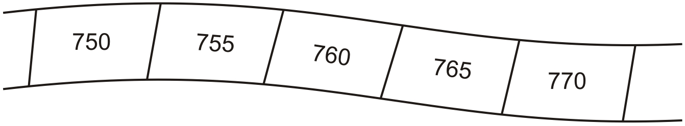
The sequence continues.
Circle all of the numbers below that would appear in the sequence.
840 905 989 1000 2051
1 mark
Q23.

Nisha says,
‘When you halve any even number,
the answer is always an odd number’.
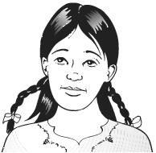
Is she correct?
Circle Yes or No. Yes / No
Explain how you know.
1 mark
Q24.

The numbers in this sequence increase by 7 each time.
1 8 15 22 29 ....
The sequence continues in the same way.
Will the number 777 be in the sequence?
Circle Yes or No. Yes / No
Explain how you know.

1 mark
Q25.

Liam makes a sequence of numbers starting with 300
He subtracts 125 each time.
Write the next two numbers in Liam’s sequence.

300 | 175 | 50
2 marks
Q26.

The numbers in this sequence increase by the same amount each time.
Write in the missing numbers

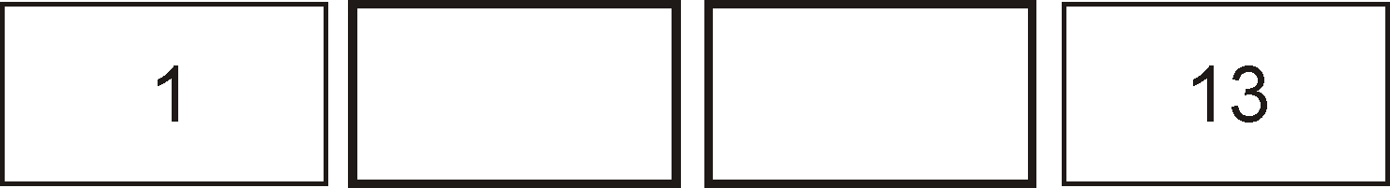
1 mark
Q27.

A sequence of numbers starts at 11 and follows the rule
'double the last number and then subtract 3'
11 19 35 67 131 ...
The sequence continues.
The number 4099 is in the sequence.
Calculate the number which comes immediately before 4099 in the sequence.

2 marks
Q28.

Josh has some tiles.

Not actual size
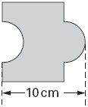
Each tile is 10 cm long.

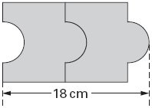
Two tiles fitted together are 18 cm long.

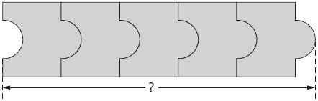
Calculate the length of five tiles fitted together.

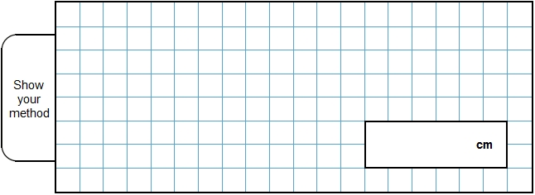
2 marks
Q29.

Here is a repeating pattern of shapes.
Each shape is numbered.


The pattern continues in the same way.
Write the numbers of the next two stars in the pattern.
1 mark
Complete this sentence.
Shape number 35 will be a circle because ...

1 mark
Q30.

Hayley makes a sequence of numbers.
Her rule is
'find half the last number then add 10'
Write in the next two numbers in her sequence.

36 | 28 | 24
2 marks
Q31.

Debbie has a pack of cards numbered from 1 to 20
She picks four different number cards.


Exactly three of the four numbers are multiples of 5
Exactly three of the four numbers are even numbers.
All four of the numbers add up to less than 40
Write what the numbers could be.


1 mark
Q32.

The first two numbers in this sequence are 2.1 and 2.2
The sequence then follows the rule
‘to get the next number, add the two previous numbers’
Write in the next two numbers in the sequence.

2.1 | 2.2 | 4.3 | 6.5
2 marks
Q33.

Write the two missing numbers in this sequence.
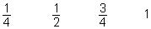  2
1 mark
Q34.

Here is part of a calendar.
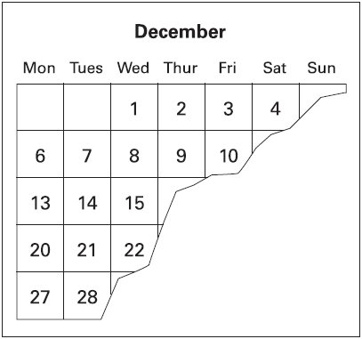
Tyrone’s birthday is on December 18th.
On what day of the week is Tyrone’s birthday?
1 mark
Q35.

Write in the missing number.
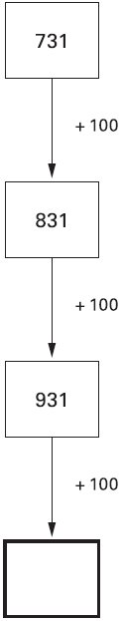
1 mark

Mark schemes
Q1.
Award ONE mark for the correct order, as shown:
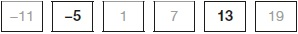
Do not accept 5−
[1]
Q2.
Award ONE mark for the table completed with the three correct answers, as shown:

Number of weeks | Number of days
1 | 7
2 | 14
4 | 28
6 | 42
10 | 70
15 | 105
[1]
Q3.
Award ONE mark for the correct order, as shown:

75 | 50 | 25 | 0 |  | −25
Do not accept 25−
[1]
Q4.
Award ONE mark for the correct order, as shown:
1,780 1,880 1,980 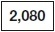 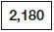
[1]
Q5.
Award TWO marks for three correct numbers, as shown:
Award ONE mark for:
• any TWO numbers correctly placed
OR
• if box 1 is correct, accept correct follow-through for box 3 from the incorrect value in box 2.
Do not accept misreads for this question.
Up to 2m
[2]
Q6.
Also accept equivalent decimal answers, e.g. 10.5 OR 10.50
[1]
Q7.
(a) 11 written in the first box, as shown:
1
(b) 109 written in the last box, as shown:
1
[2]
Q8.
Explanation that recognises that the sequence does not always increase by four, with clear reference to the data, e.g.
• The difference between 1996 and 1999 is three years, not four so it is not always every four years
• It would be 2000 if it was every 4 years
• It should have ended in 2016
OR
Explanation that demonstrates that the sequence does not always increase by 4, but does not reference specific years from the data, e.g.
• The cricket world cup was sometimes 3 years apart instead of 4 years apart
• Not all of the years have 4 years difference between.
Do not accept vague or incomplete explanations, e.g.
• It does not always increase by four
• It should be 2000
• The difference can be 3, 4 or 5 years at different times.
Do not accept explanations which include incorrect mathematics or incorrect information that is relevant to the explanation, e.g.
• 1992 + 4 = 1996 + 3 = 1999
[1]
Q9.
299,604
[1]
Q10.
Award TWO marks for three correct numbers, as shown:

35 | 42 | 49 | 56 | 63 | 70
Award ONE mark for two numbers correctly placed.
Up to 2m
[2]
Q11.
Award TWO marks for three numbers correct as shown:

19 |  | 38 |  | 76 |  | 152 |  | 304
If the answer is incorrect, award ONE mark for two numbers correct.
Up to 2
[2]
Q12.
(a) X = 125
1
(b) Y = -75
Do not accept 75−
1
[2]
Q13.
Award TWO marks for the correct answer of 290
If the answer is incorrect, award ONE mark for evidence of appropriate working, eg:
■ 110 140 170 200 230 260 290 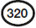
Not spotting closest number.
OR
■ 110 140 170 190 220 250 280 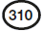
One step size incorrect (170 to 190).
OR
■ 300 + 20 = 320
320 - 30 = wrong answer
Working must be carried through to reach an answer for the award of ONE mark.
Up to 2
U1
[2]
Q14.
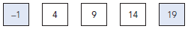
[1]
Q15.
(a) Two numbers from the sequence that total 96, eg:
43 AND 53
OR
23 AND 73
Numbers may be given in either order.
Accept negative numbers, eg −7 AND 103
1
(b) An explanation that recognises that adding three numbers ending in 3
will produce a number ending in a 9 eg:
■ ‘They all end in 3 so adding three will give a number ending in 9’
■ ‘If you add three numbers in the sequence you will always get a
number ending in 9’
■ ‘All the numbers are odd and 96 is even’
Do not accept vague or incomplete explanations, eg:
■ ‘All the numbers end in three’
■ ‘It only works with two numbers’
■ ‘3 odds add to make an even’
U1
[2]

Q16.
(a) 570 in the first box.
1
(b) 730 in the last box
1
[2]

Q17.
Award TWO marks for the sequence completed correctly as shown:

1 |  |  |  | 4 |  |  |  | 7
If the answer is incorrect, award ONE mark for two numbers correct.
Up to 2
[2]
Q18.
Two numbers circled as shown:
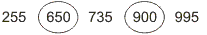
Accept alternative unambiguous indications, eg numbers ticked, crossed or underlined.
[1]
Q19.
20
1
33.125
Accept equivalent fractions or decimals
1
U1
[2]

Q20.
An explanation which gives a counter-example to illustrate that halving a number that ends in 8 does not always give a number ending in 4, eg:
• ’18 doesn’t work’
• ‘It could end in a 9’
• ‘Double 49 is 98’
• ’58 ÷ 2 = 29’
• ‘Half of 8 is 4 but half of 18 doesn’t end in 4’
• ’18, 28, 38, 48, 58, 68 – only half of them work’
• ‘It has to have an even number of 10s, like 28 or 88’
• ‘38’
No mark is awarded for circling ‘No’ alone.
Do not accept vague or incomplete explanations, eg:
• ‘Half of them don’t’
• ‘Half of 28 is 14’
• ‘Double 44 is 88’
If ‘Yes’ is circled but a correct, unambiguous explanation is given, then award the mark.
U1
[1]
Q21.
Award TWO marks for a multiple of 15 which is greater than 100, eg
105 OR 120 OR 135 OR 150 OR 300
Accept more than one answer if all are correct.
If the answer is incorrect, award ONE mark for evidence of appropriate method, eg:
Accept for ONE mark 30, 45, 60, 75 OR 90
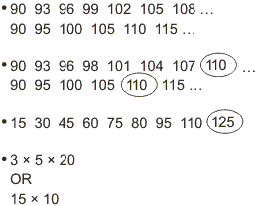 | ← Not spotting matching number (105)  ← One step size incorrect (96 to 98)  ← One step size incorrect (75 to 80)  ← Multiple greater than 100 but not calculated
Answer need not be obtained for the award of ONE mark.
Up to 2
[2]
Q22.
Three numbers circled as shown:
Do not award the mark if additional incorrect numbers are circled.
Accept: alternative unambiguous indications, eg numbers ticked, crossed or underlined.
U1
[1]
Q23.
An explanation which recognises that half of an even number is sometimes
an even number, eg:
• ‘Every alternate even number gives an even number when halved’
• ‘Two even numbers make an even number’
• ‘Half of a multiple of 4 will always be even’
• ‘Sometimes you get an even number’
OR
a counter-example demonstrating that half of an even number can be an even
number, eg:
• ‘Half of 8 is 4’
• ‘4 ÷ 2 = 2’
• ‘Double 10 is 20’
• ‘Half 12 is 6 but half 6 is 3’.
No mark is awarded for circling ‘No’ alone.
Do not accept vague or incomplete explanations, eg:
• ‘It doesn’t always work’
• ‘It’s always even’
• ‘Half of 6 is 3’
• ‘Two odds make an even’.
If ‘Yes’ is circled but a correct unambiguous explanation is given, then award the mark.
U1
[1]
Q24.
‘No’ is circled AND one of the following:
an explanation which recognises that 777 is not one more than a multiple of 7, eg:
• ‘All the numbers are one more than a multiple of 7’
• ‘There are no multiples of 7 in the sequence’
• ‘778 is in the sequence’
• ‘771 works but 777 doesn’t’
OR
an explanation which recognises that 777 is a multiple of 7, eg:
• ‘777 is a multiple of 7’
• ‘777 ÷ 7 = 111’
OR
an explanation which relies solely on the start of the sequence, eg:
• ‘The sequence started at 1’
• ‘The sequence doesn’t start at 0’.
‘No’ must be indicated for the award of the mark, unless a complete and correct explanation is given, eg:
• ‘777 is a multiple of 7, and the numbers in the
sequence aren’t’.
No mark is awarded for circling ‘No’ alone.
Do not accept vague or incomplete explanations, eg:
• ‘It’s adding 7 every time’
• ‘There are no 7s in the sequence’.
U1
[1]
Q25.
(a) –75 in the first box
Do not accept 75–
1
(b) –200 in the second box
Do not accept 200–
Accept a number 125 less than the answer to (a), provided the answer to 18a is negative.
1
[2]
Q26.
[1]
Q27.
Award TWO marks for the correct answer of 2051
If the answer is incorrect, award ONE mark for
evidence of appropriate method, eg
(4099 + 3) ÷ 2
OR
continuation of sequence, eg
259, 515, 1027, wrong number
Answer need not be obtained for the award of ONE mark.
Up to 2
[2]
Q28.
Award TWO marks for the correct answer of 42
If the answer is incorrect, award ONE mark for evidence of appropriate
working, eg
18 – 10 = 8
10 + (4 × 8) = wrong answer
OR
10, 18, 26, 34, wrong answer
Calculation must be performed for the award of ONE mark.
Up to 2
[2]
Q29.
(a) AND
1
(b) An explanation which recognises that the numbers in circles
are multiples of 5, eg
• Because all the circles are multiples of 5.
• Because 35 is in the five times table.
Both numbers must be correct for the award of the mark.
Answers may be written in either order.
Do not accept vague or arbitrary explanations, eg
• ‘Because you keep on adding 5’;
• ‘Because the circles are 5 more each time’.
U1
[2]
Q30.
Award TWO marks for the correct answer of
If the answer is incorrect, award ONE mark for
either
22 in the first box
or
a number in the second box, which is 10 more than half the answer given in the first box.
Numbers must be in the correct order.
Up to 2
[2]
Q31.

OR

Accept the four numbers listed in any order.
U1
[1]
Q32.
Award TWO marks for the correct answer of
If the answer is incorrect, award ONE mark for
either
1 m 0.8 in the first box
or
a number in the second box, which is 6.5 greater than the answer given in the first box.
Numbers must be in the correct order.
Up to 2
[2]
Q33.
Boxes completed as shown:
 |  |  | 1 | 1 | 1 | 1 | 2
Both numbers must be correct for the award of the mark.
[1]
Q34.
Saturday
Accept any reasonable spelling as long as the intention is clear.
[1]
Q35.
1031
[1]

