Mr Drew
[Company name] [Company address]
SPAG Revision booklet

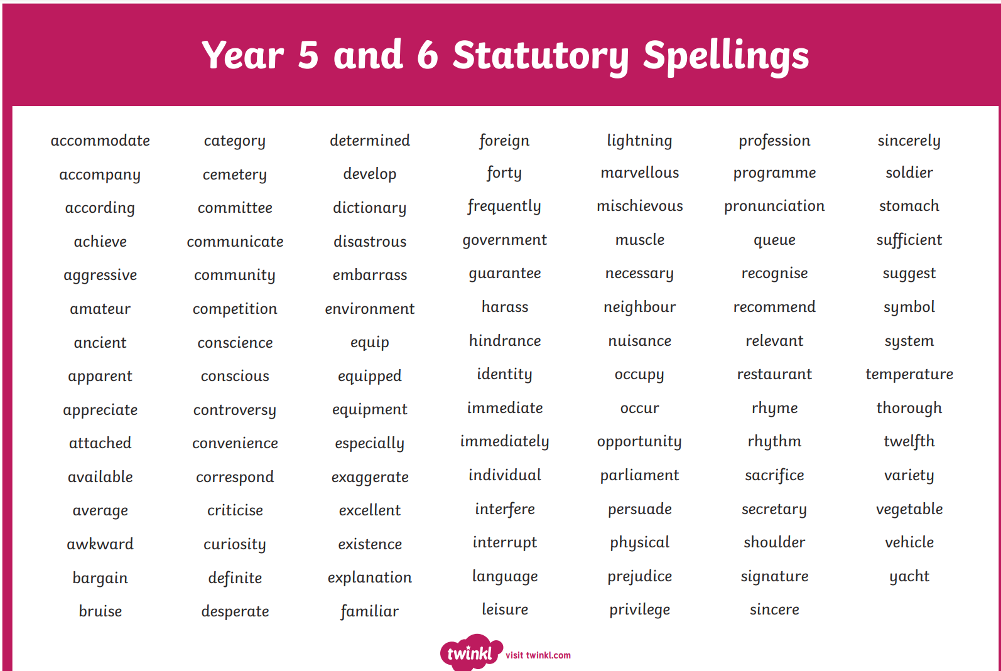
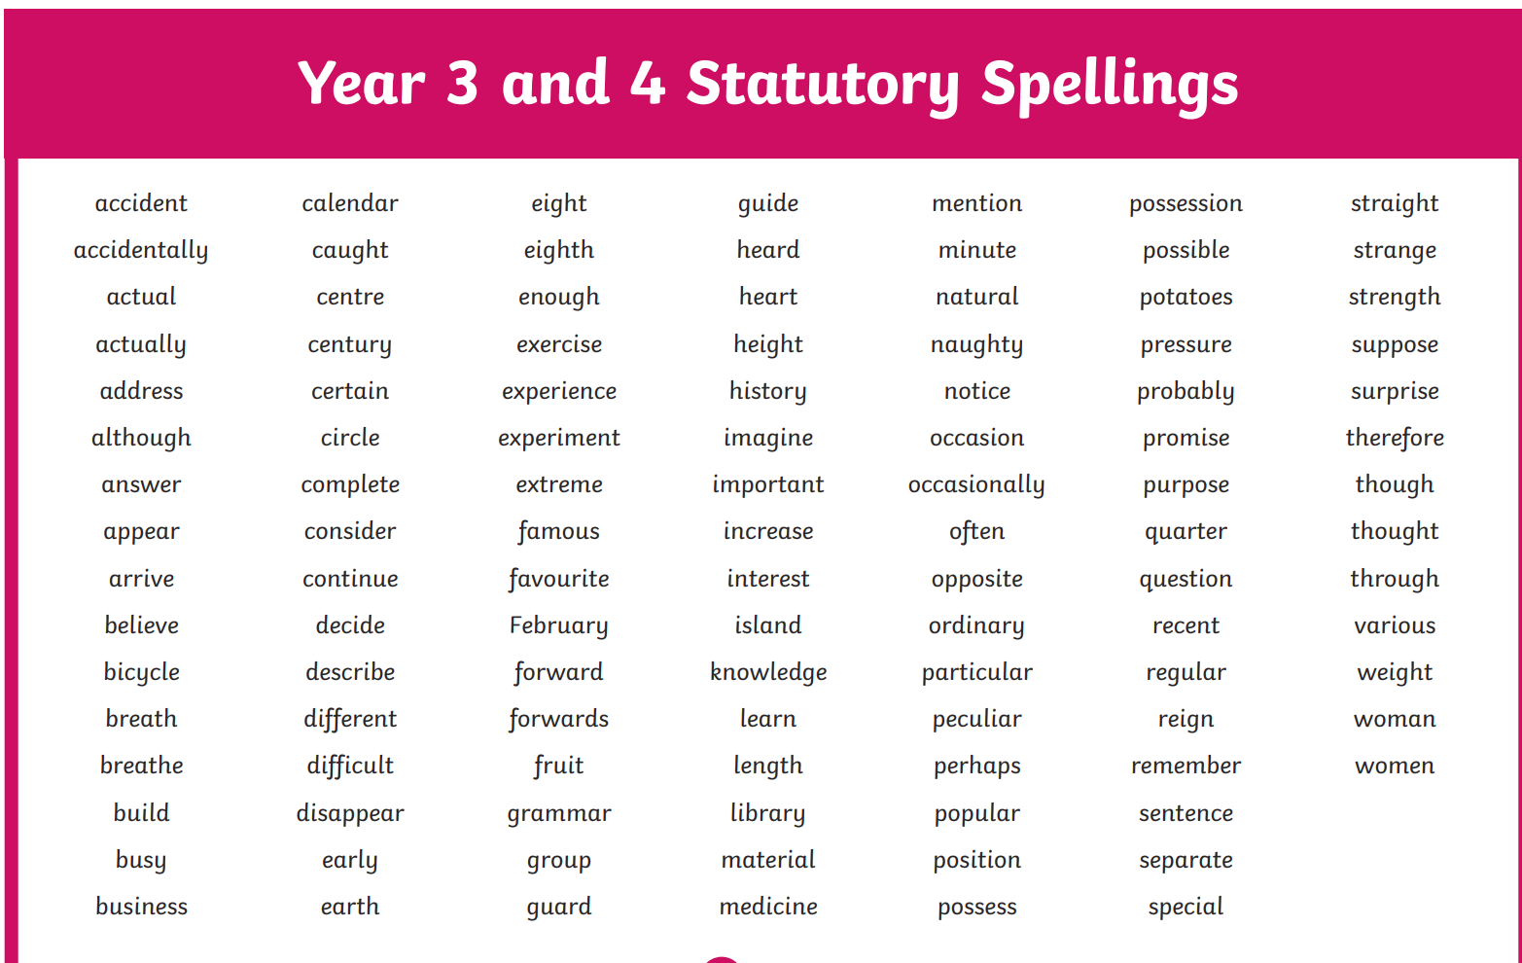
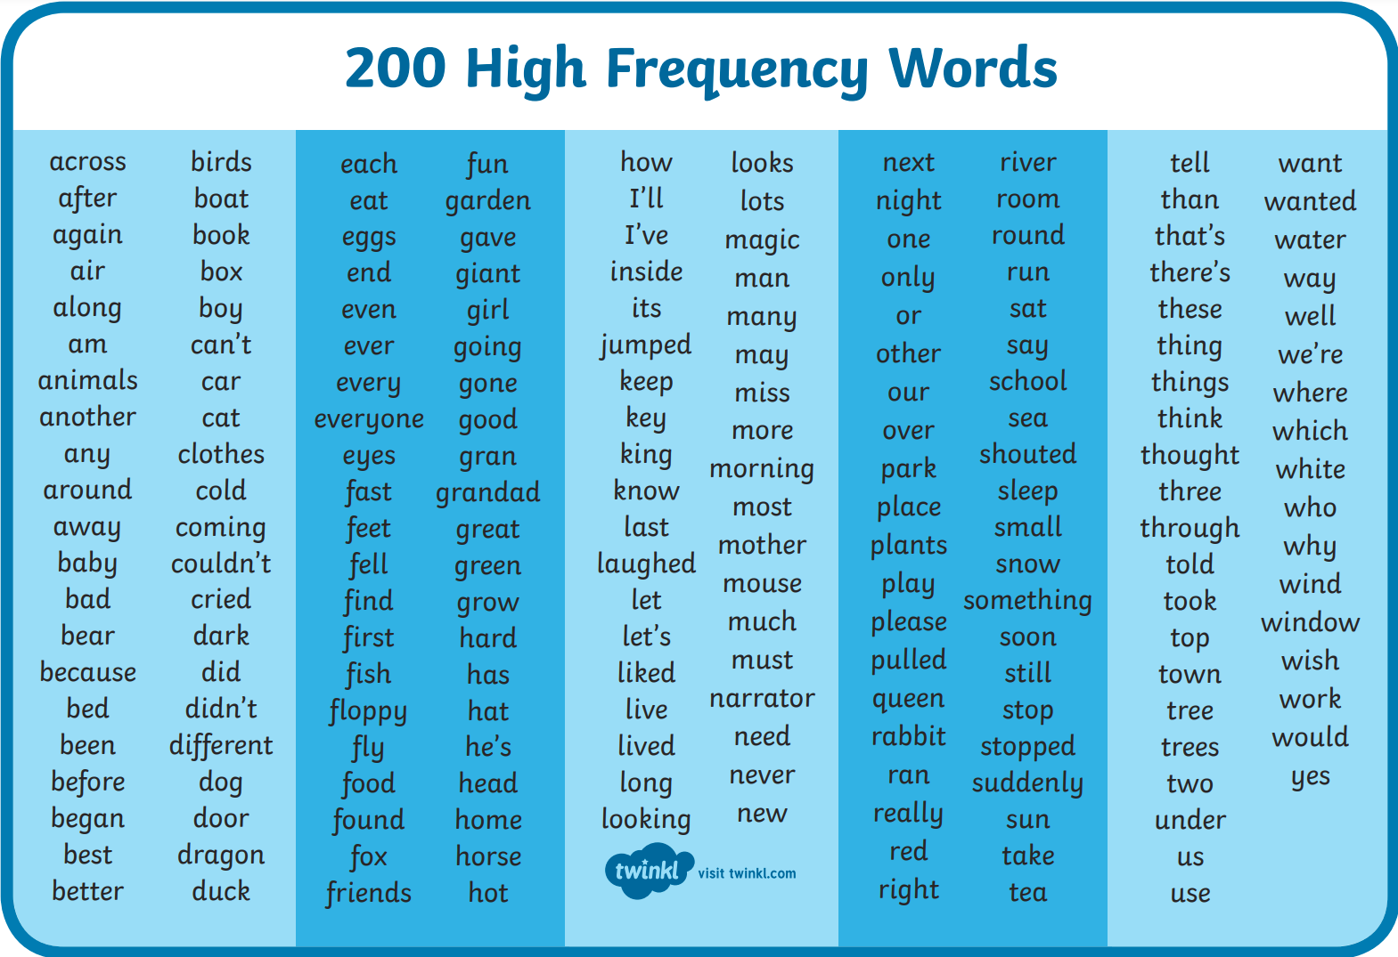
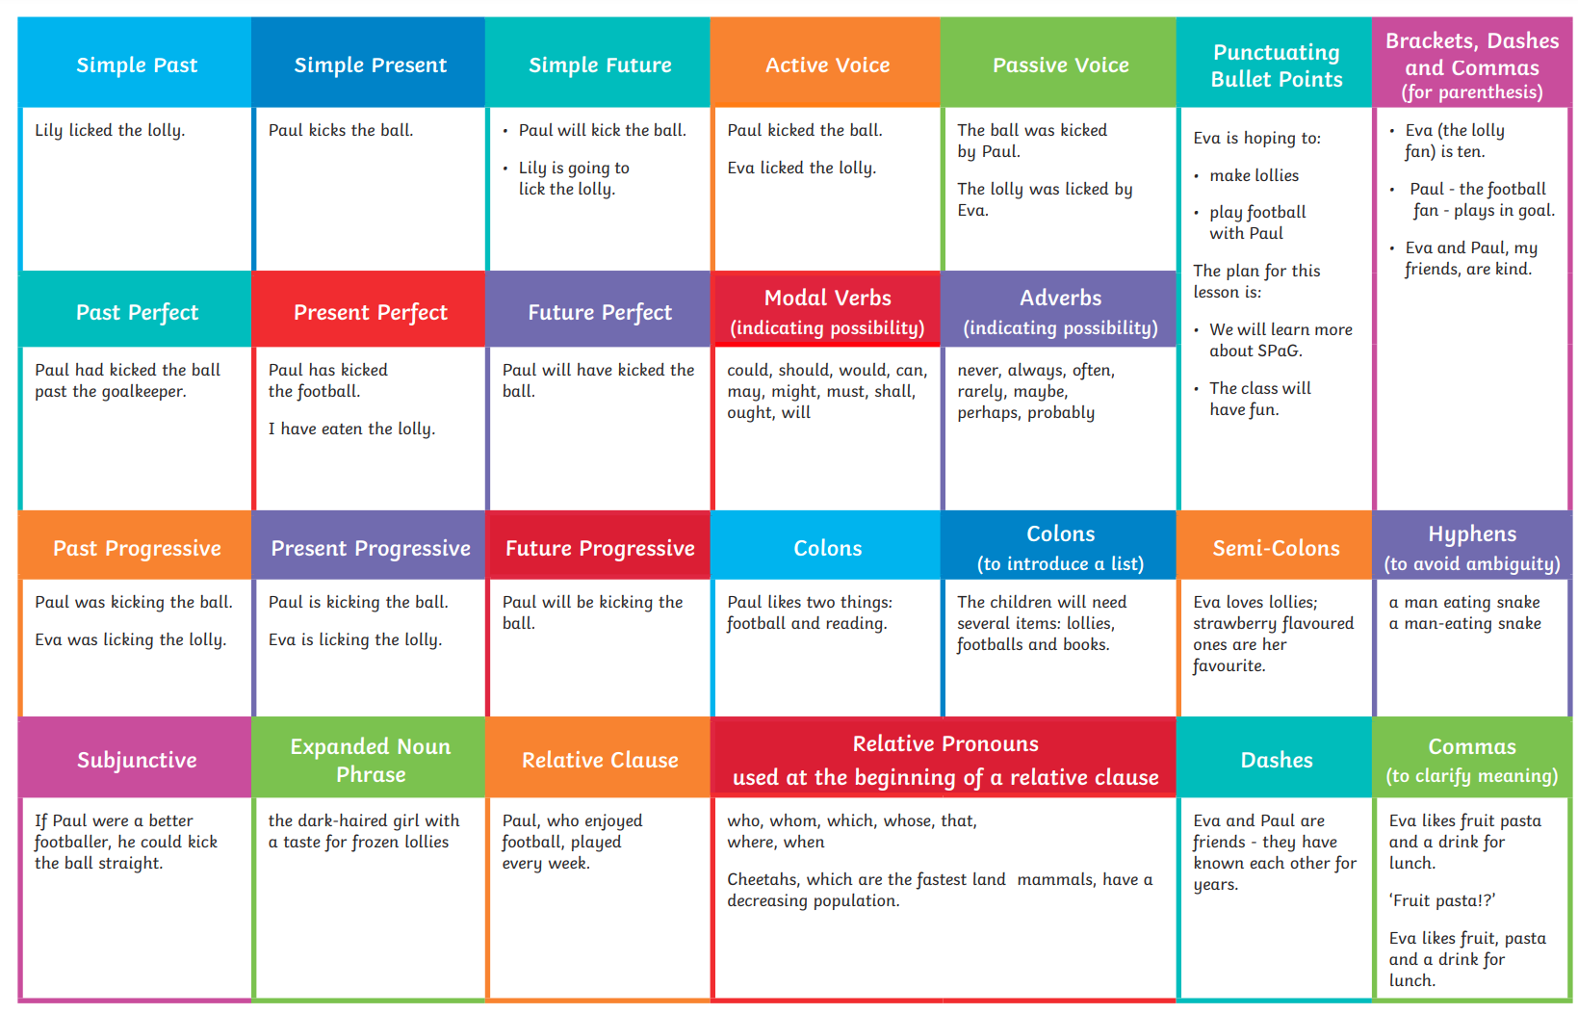
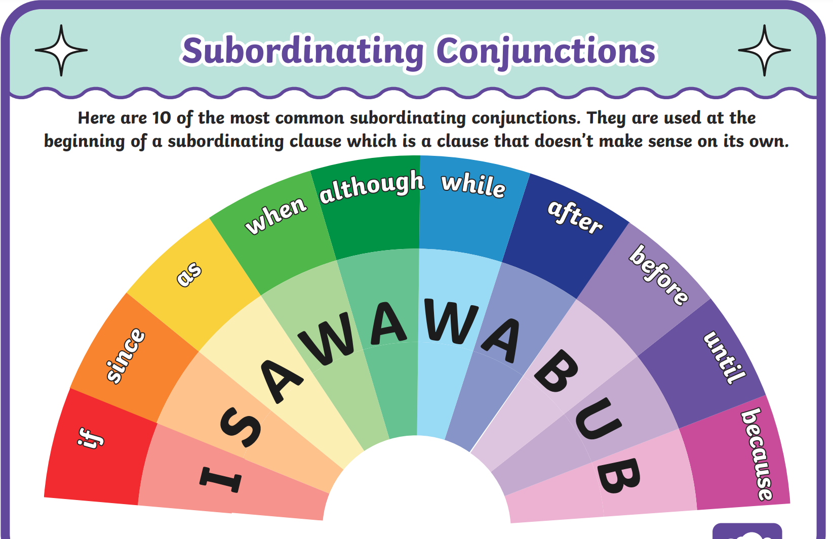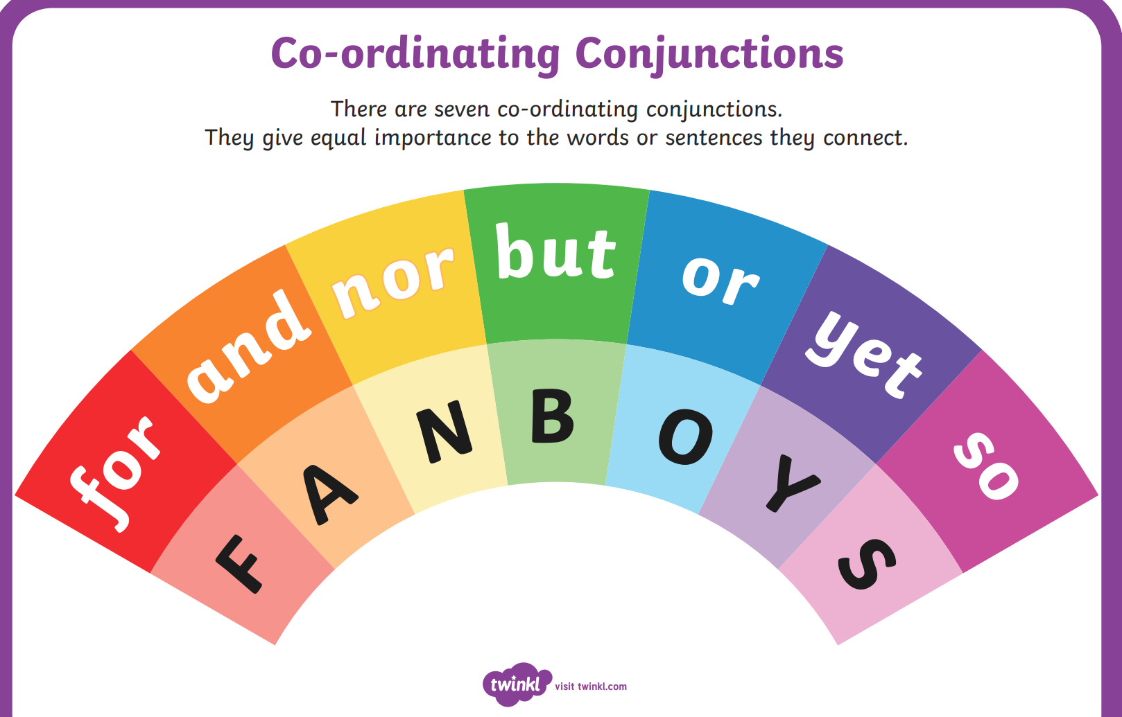

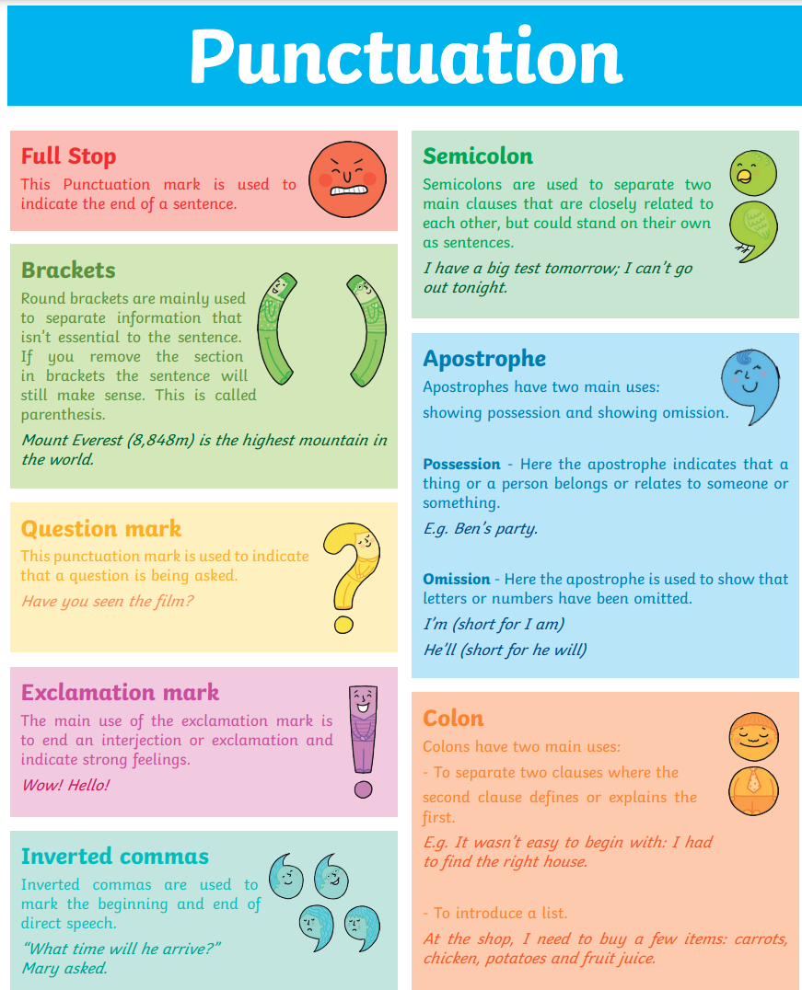

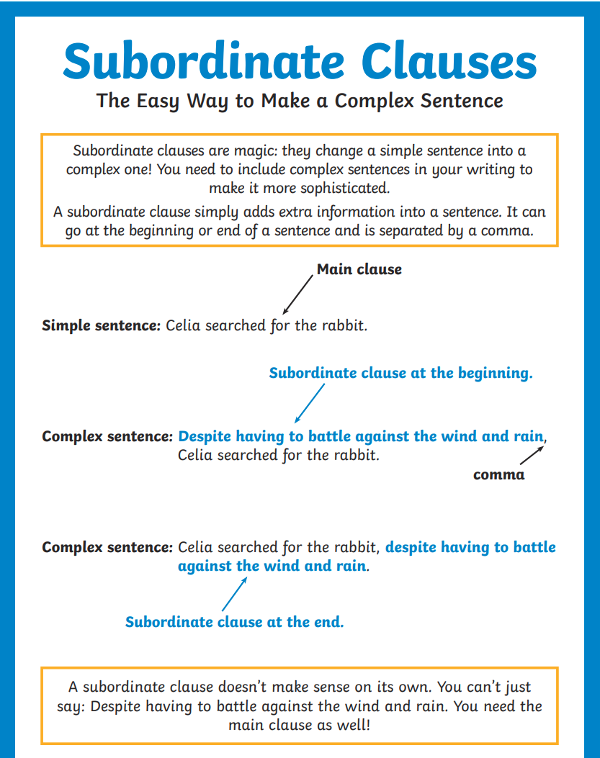

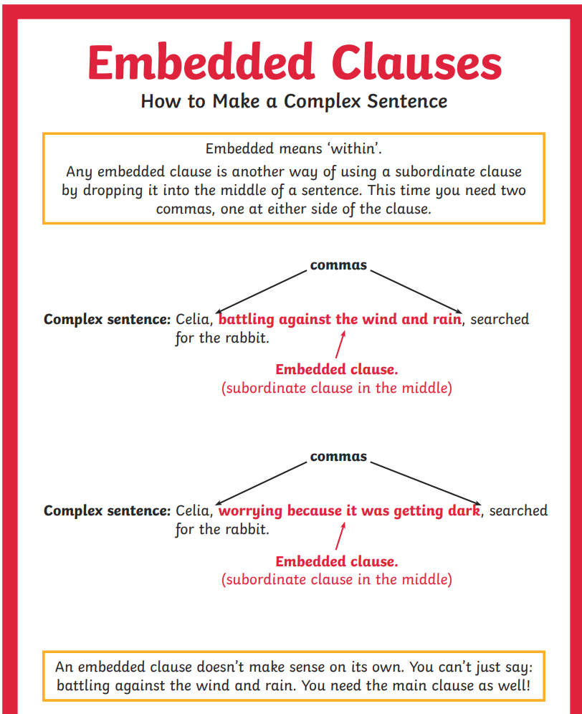

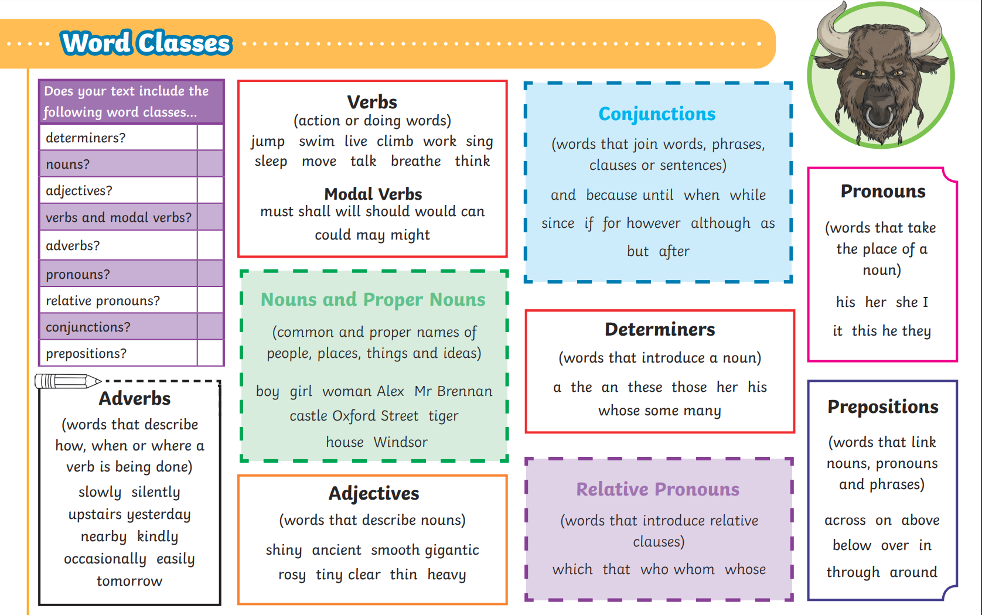

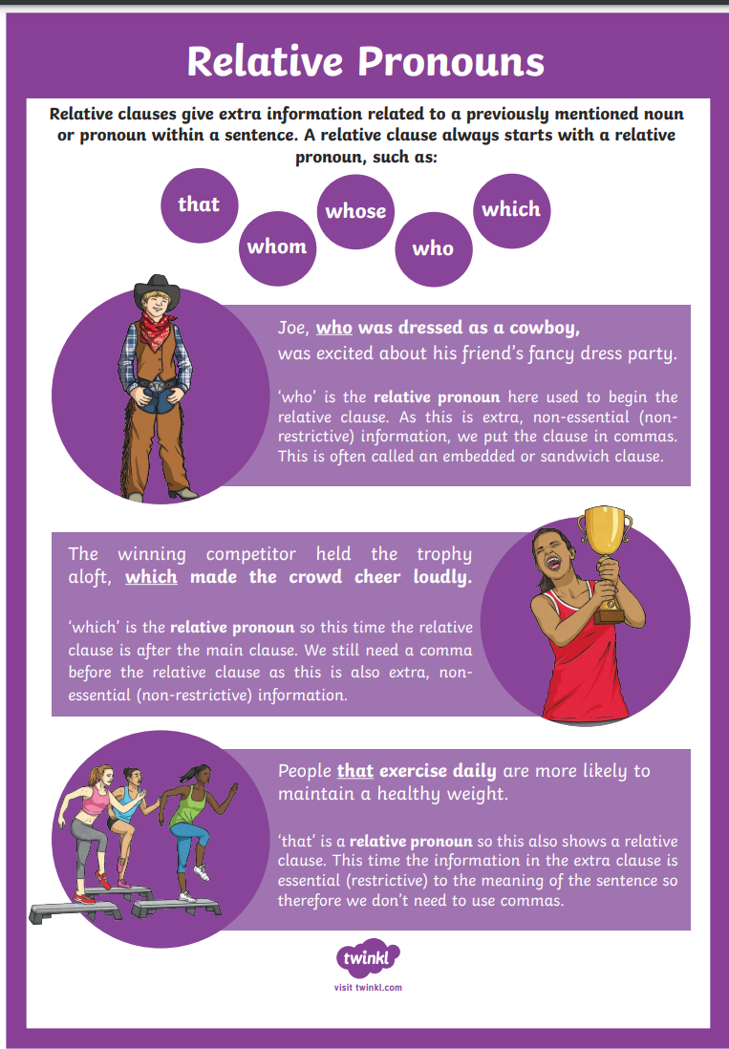

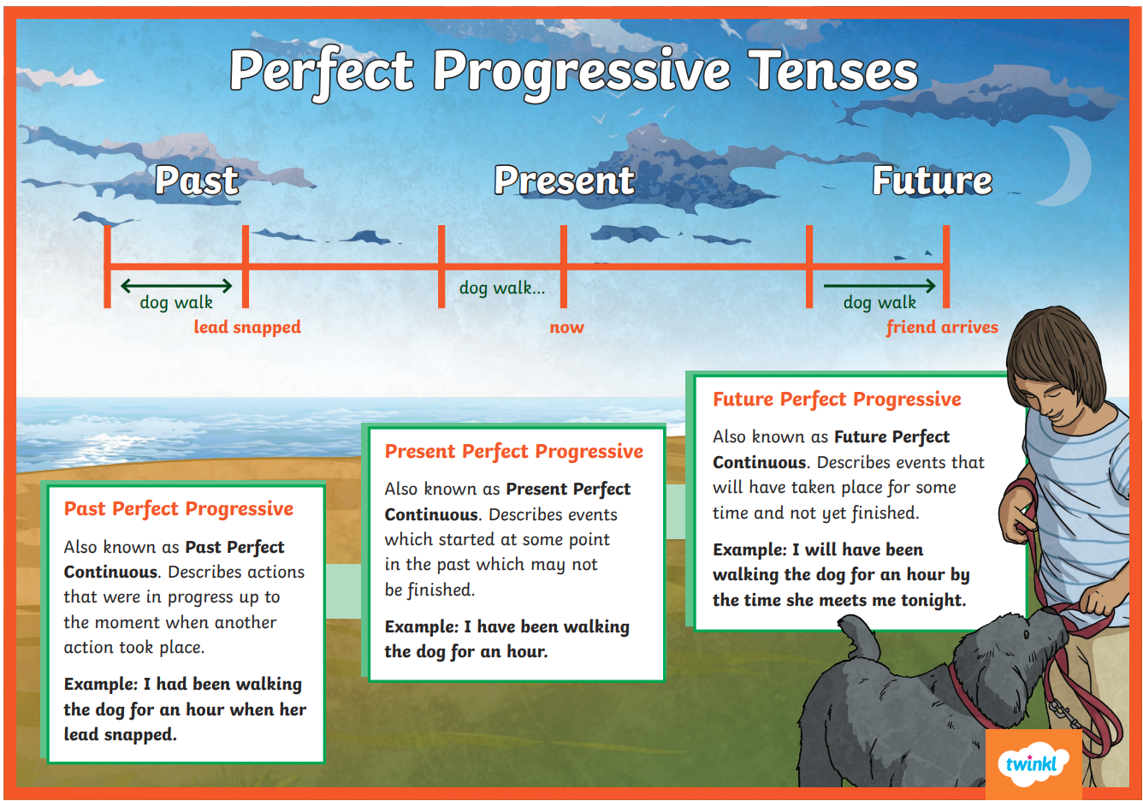
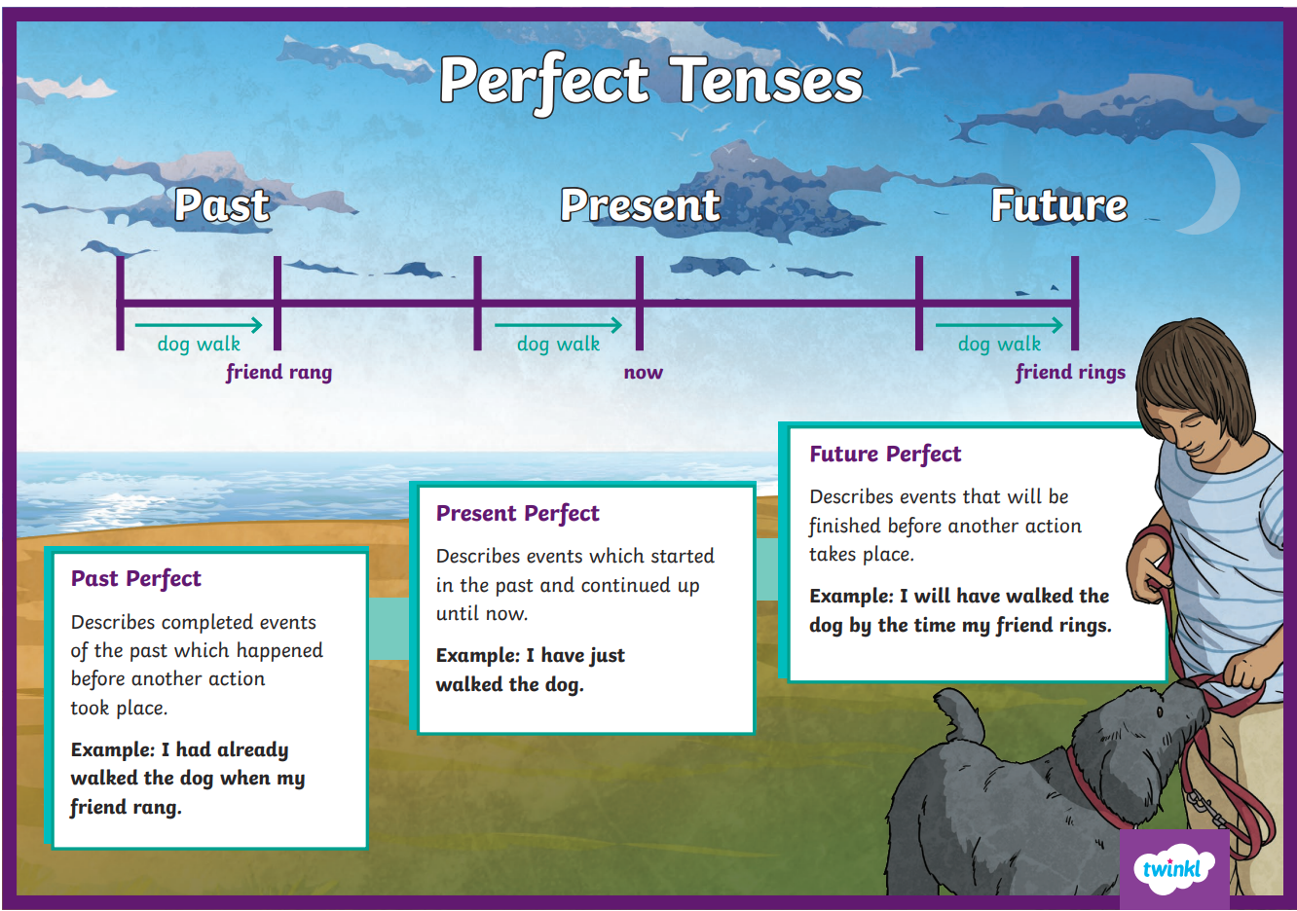

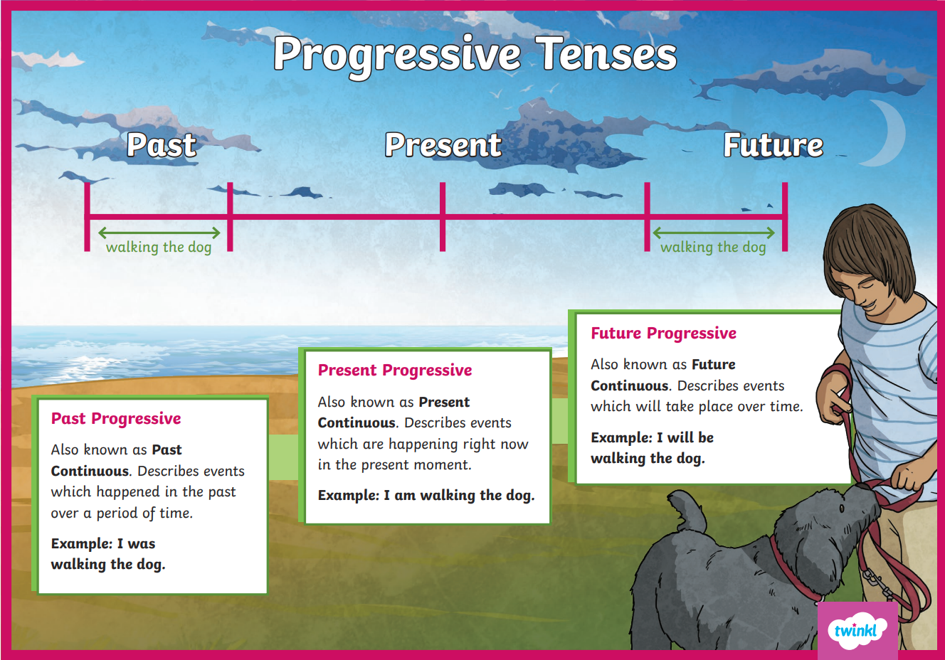
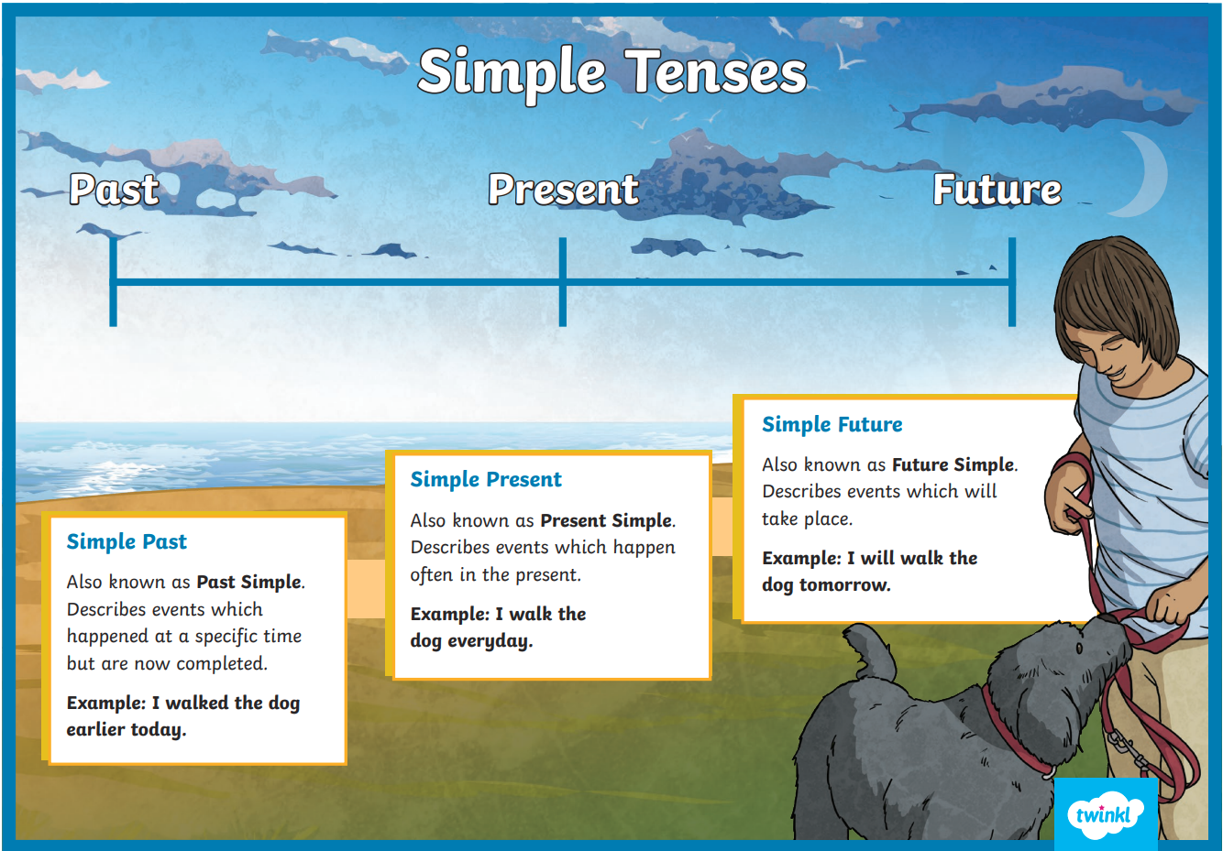

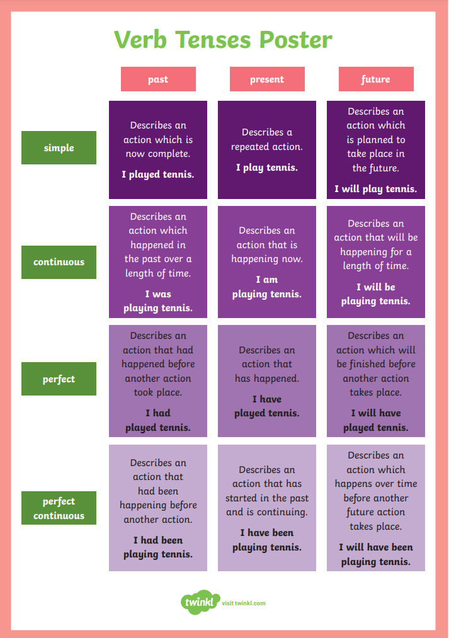

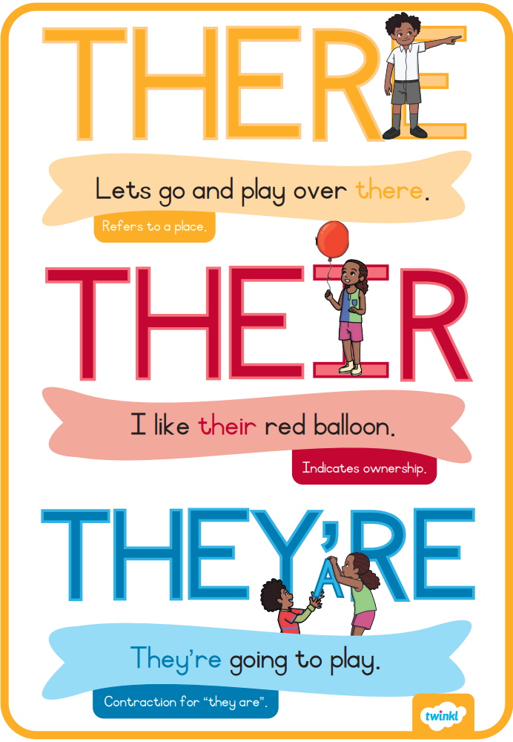

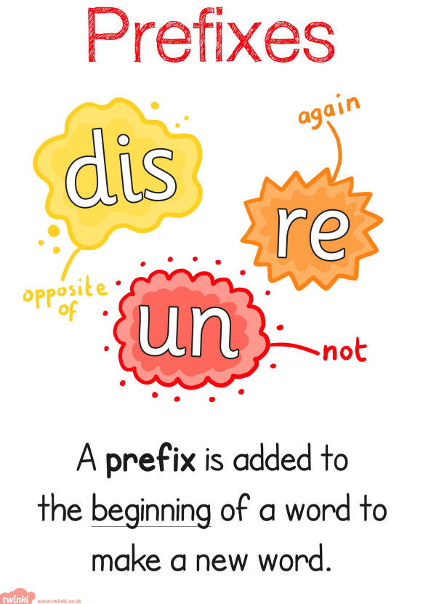

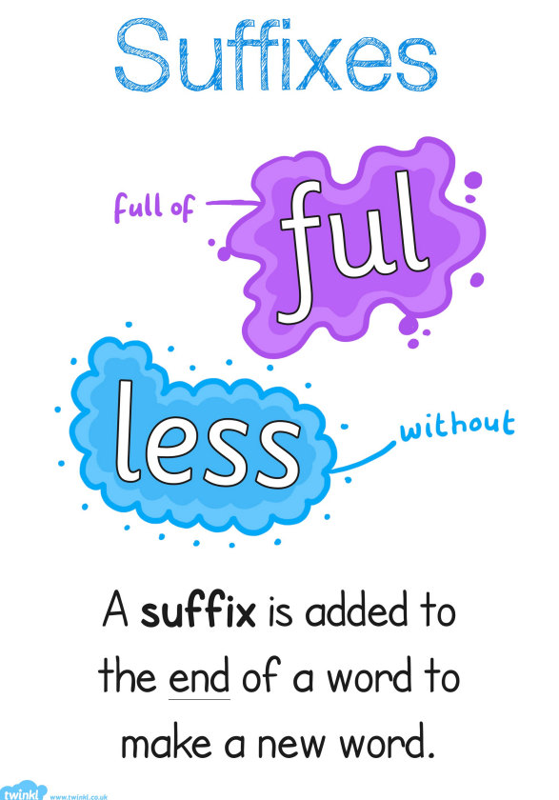

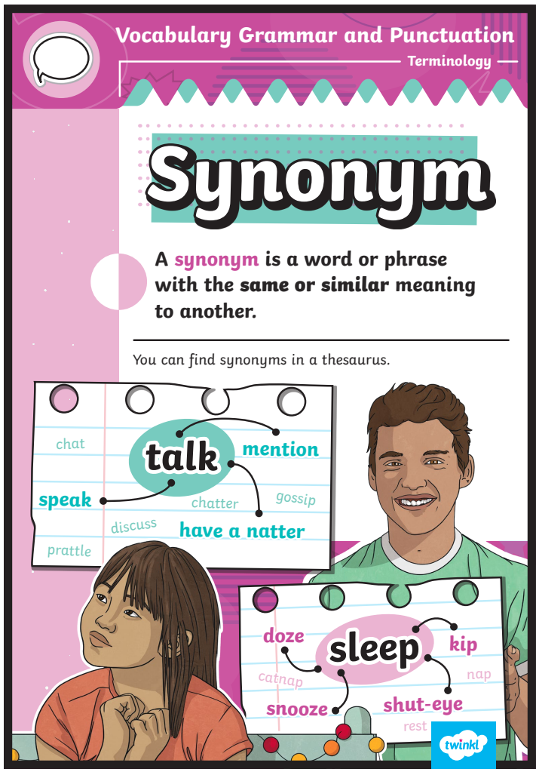

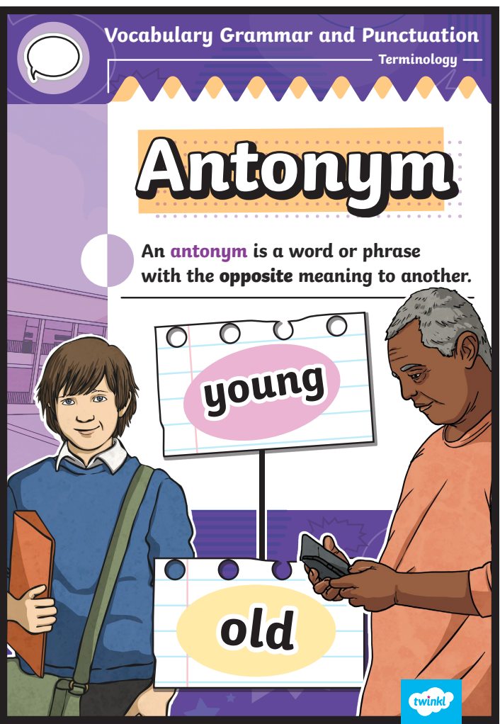

Q1.
The sentences below have their punctuation marks covered.
Which sentence is a command?

 | Tick one.
Throw the ball | 
You could throw the ball
Can we throw the ball
How big that ball is
Q2.
Write the present tense of rode in the box.
The children rode their bikes.
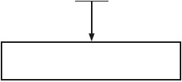

Q3.
Tick the word that completes the sentence.
You can join the red team __________ the green team.

Tick one.
because
but
or
when
1 mark
Q4.
Add the correct punctuation mark in the box below.
Are we going to the shops now
1 mark
Q5.
Tick the adjective in the sentence below.
Anna shut the heavy door in a hurry.
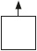
1 mark
Q6.
Add two full stops in the correct places below.
Amir gave a picture to his sister Zara really liked it
1 mark

Q7.
Tick one box to show where the comma should go in the sentence below.
We play with balls bats or hoops in the afternoon.
1 mark
Q8.
What type of sentence is below?
A wild forest surrounded the castle.

Tick one.
a question
an exclamation
a statement
a command
1 mark
Q9.
Circle one word in the sentence below that can be replaced with the word if.
When it is cold, I wear a warm coat and a hat.
1 mark
Q10.
Why does the underlined word start with a capital letter?
This afternoon, we will play games outside.
_______________________________________________________________________
1 mark
Q11.
The sentences below have their punctuation marks covered.
Tick to show which two sentences are questions.

Tick two.
What a hot day it is today
When you go, put your coat on
Where did I put my bag
How excited I am
How did you guess where I was hiding
1 mark
Q12.
Circle the noun in the sentence below.
The beautiful stars are shining brightly.
1 mark
Q13.
Which sentence should end with an exclamation mark?

Tick one.
What time does the match start
What a great goal he scored
How are you getting there
How did he score from there
1 mark
Q14.
Write one word, using an apostrophe, to show that the football belongs to Dom.
This is _________________ football.
1 mark
Q15.
Write the past tense of the word borrow on the line below.
I _________________ three books from the library.
1 mark
Q16.
Add an apostrophe to the sentence below in the correct place.
R i a w a s n t l a t e t o d a y.
1 mark
Q17.
What type of word is underlined in the sentence below?
Put the pens away neatly.

Tick one.
a noun
a verb
an adjective
an adverb
1 mark
Q18.
Circle the verbs in the sentence below.
Anna read a funny poem and everyone laughed.
1 mark
Q19.
Tick one box in each row to show if the sentence is in the past tense or the present tense.

Sentence | Past tense | Present tense
Alex was planting some seeds.
Alex planted some seeds.
Alex is planting some seeds.
Alex plants some seeds.
1 mark
Q20.
Tick to show the correct plural ending for each underlined word.

Word | s | es
We put the dish on the table.
We tied ribbon around the present.
We took the parcel to the post office.
1 mark

Q21.
Tick the sentence below that has a noun phrase.

Tick one.
He was sleepy and tired.
He wore a red jumper.
He wanted to be kind.
He was very excited.
1 mark
Q22.
Add capital letters and a full stop to correct the sentence below.
the pool is shut on fridays
1 mark
Q23.
Tick the sentence below that is punctuated correctly.

Tick one.
The ball rolled across the playground
the ball rolled across the playground.
The ball rolled across the playground.
the ball rolled across the playground

Q24.
Look at where the arrow is pointing.
What a delicious cake we ate!
What is the punctuation mark called?
_______________________________________________________________________
Q25.
Which sentence is a command?

Tick one.
The weather is sunny today.
My cat plays in the sunshine.
Open the door for her.
She likes to sit outside.
1 mark
Q26.
Which sentence can be completed with the word or?

Tick one.
We will go later _______ the sun comes out.
Shall we go for a walk _______ stay at home?
Can we go out _______ it stops raining?
That is a good idea _______ I don’t have a coat.
1 mark
Q27.
Add a suffix to make the word safe an adverb.
Josie and her mum crossed the road safe ____________.
1 mark
Q28.
Circle one full stop that can be replaced with the word because.
I want to be a vet. I like animals. Mr Smith says it is
hard work. Mum thinks that I will enjoy the job.
1 mark
Q29.
What type of word are Vaz and Harry talking about below?
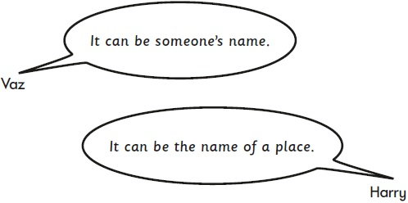

Tick one.
an adjective
a verb
a noun
an adverb
1 mark
Q30.
The underlined verb is in the wrong tense.
Write the verb in the correct tense in the box below.
After the children made their models, they paint them.
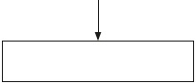
1 mark
Q31.
Tick two suffixes that can be added to the word small to make two different words.

Tick two.
ful
er
ly
ment
est
1 mark
Q32.
Circle the two adjectives in the sentence below.
The seed grows small roots, followed by a strong stem.
1 mark

Q33.
Which sentence uses a comma correctly?

Tick one.
Bring a pencil a ruler and, a book to school.
Bring a pencil a ruler, and a book to school.
Bring, a pencil a ruler and a book to school.
Bring a pencil, a ruler and a book to school.
1 mark
Q34.
Circle the verb that is written in the past tense.
Ben learnt that some whales can hold their breath for
two hours.
1 mark
Q35.
Circle the verb in the sentence below.
Hiba took some pictures for her project.
1 mark
Q36.
Which word should have an apostrophe?
Tick one.
The boys parents were checking his homework.
1 mark

Q37.
What is needed in the sentence below?
the boys raced to the park.

Tick one.
a capital letter
a question mark
a comma
an apostrophe
Q38.
Write one word to complete the sentence below.
I want to be a pilot _______________ I grow up.
Q39.
Draw lines to join two words that can become one word.
One has been done for you.
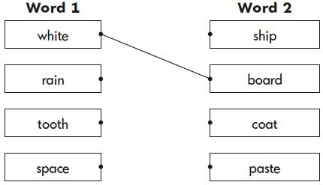
1 mark

Q40.
Which sentence is punctuated correctly?
Tick one.
There are some foxes living in the woods
there are some foxes living in the woods
There are some foxes living in the woods.
there are some foxes living in the woods.
1 mark
Q41.
Tick the correct word to complete the sentence below.
We will go cycling ____________ we arrive home in time.

Tick one.
that
or
but
if
1 mark
Q42.
Rewrite the verb in the box to complete the sentence in the correct tense.
Emily _____________ to school and met Li at the gate.
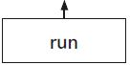
1 mark
Q43.
Tick the sentence with the correct punctuation.
Tick one.
We saw sheep cows, and birds on our walk.
We saw sheep, cows and birds on our walk.
We saw sheep cows and birds, on our walk.
We saw, sheep cows and birds on our walk.
1 mark
Q44.
What type of word is flew in the sentence below?
The green parrot flew to the top of the tree.

Tick one.
an adjective
a noun
an adverb
a verb
1 mark
Q45.
Circle the noun in the sentence below.
The talented dancer moved gracefully.
1 mark

Q46.
Tick the correct option to complete the sentence below.
_______________ going to Jasvir’s party.

Tick one.
Were’
W’ere
Wer’e
We’re
Q47.
Circle the full stop below.
The classroom display is great.
Q48.
What type of word is underlined in the sentence below?
We saw the boat move across the pond.

Tick one.
a verb
a noun
an adjective
an adverb
1 mark

Q49.
Circle the adjective in the sentence below.
The tree was taller than the house.
1 mark
Q50.
Tick the correct word to complete the sentence below.
It was raining heavily, ____________ Fatima went out to play.

Tick one.
but
if
or
that
1 mark
Q51.
What is the sentence below? The end punctuation is covered.
What a fantastic piece of work that is

Tick one.
a statement
a command
an exclamation
a question
1 mark
Q52.
The sentence below should all be in the past tense.
Circle one word that needs to be changed.
The swimming pool was closed so Ted plays in the park.
1 mark
Q53.
Circle the word that shows the sentence below is in the present tense.
The drink is very hot.
1 mark
Q54.
Circle the two words that need a capital letter in the sentence below.
last week i visited the zoo with my brother.
1 mark
Q55.

Tick one word to complete the sentence below.
Potatoes are good for you, ___________________ you should not eat chips too often.

 | Tick one.
that | 
but
when
or
1 mark

Q56.

Tick the correct word to complete the sentence below.
Sasha was running to school ____________________ she was late.

Tick one.
if
or
that
because
1 mark
Q57.

Circle the adjective in the sentence below.
Take a blue crayon from the box to colour
in the sky.
1 mark
Q58.

Add a full stop or a question mark to complete each sentence below.
There is a pony in the field 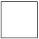
Are we going swimming
Have you seen my hat and gloves
1 mark

Q59.

Draw a line to match each word to the suffix that turns it into a noun.

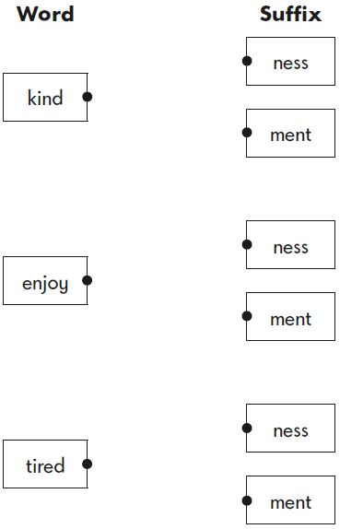
1 mark
Q60.

Add two full stops in the correct places below.
Jamie walks to school with his mum Alex
joins them
1 mark

