**St Paul’s Catholic Primary School**

**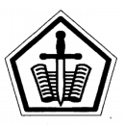**

****

**Maths Facts**

**Handbook**

The UK curriculum in mathematics is now focused on Mastery approaches. This means that children are required to develop a secure understanding of each aspect of the mathematics curriculum. This is achieved by challenging children with rich and sophisticated problems to ensure that the learning is securely embedded.

With this in mind, the first step achieving this comes from having a secure knowledge of basic facts and mathematical processes. These facts and processes have been incorporated into this Maths Facts Handbook.

**Contents**

|  |
| --- |
| 1. **Numbers** 2. **Measurement** 3. **Time** 4. **Shape** 5. **Area** 6. **Calculations** 7. **Glossary** |

|  |
| --- |
| **The Number System** |

|  |  |  |  |  |  |  |  |
| --- | --- | --- | --- | --- | --- | --- | --- |
| Millions | | Thousands | | | Ones | | |
| Ten Millions | Millions | Hundred Thousands | Ten Thousands | Thousands | Hundreds | Tens | Ones |
|  | 3 | 2 | 4 | 5 | 7 | 6 | 9 |

3 245 769 is three million, two hundred and forty five thousand, seven hundred and sixty nine.

The 5 stands for five thousand and the 2 stands for two hundred thousand.

|  |  |  |  |  |  |
| --- | --- | --- | --- | --- | --- |
| Ones | | | Fractions | | |
| Hundreds | Tens | Ones | Tenths | Hundredths | Thousandths |
|  | 2 | 7 | 3 | 9 | 8 |

In the number 27.398, the 3 stands for three tenths, the 9 stands for nine hundredths and the 8 stands for eight thousandths. Note the Fractions are read as a single number.

|  |
| --- |
| **Fractions** |

Fractions are numbers that include part of a whole number, they are written as numerator or numerator

Denominator Denominator

The denominator tells you how many divisions make a whole number

|  |  |  |  |  |
| --- | --- | --- | --- | --- |
| 1 Whole |  | 1 Whole |  | 1 Whole |

|  |  |  |  |  |  |  |  |  |  |  |  |  |  |  |
| --- | --- | --- | --- | --- | --- | --- | --- | --- | --- | --- | --- | --- | --- | --- |
|  |  |  |  |  |  |  |  |  |  |  |  |  |  |  |

3 divisions ?/3 4 divisions ?/4 6 divisions ?/6

The numerator tells you how many divisions are selected

|  |  |  |  |  |  |  |  |  |  |  |  |  |  |  |
| --- | --- | --- | --- | --- | --- | --- | --- | --- | --- | --- | --- | --- | --- | --- |
|  |  |  |  |  |  |  |  |  |  |  |  |  |  |  |

3 divisions, 2 selected 4 divisions , 3 selected 6 divisions, 1 selected

2/3 3/4 1/6

|  |  |  |
| --- | --- | --- |
| **Equivalent** | | |
| **Fractions** | **Decimals** | **Percentages** |
| 1/2 | 0.5 | 50% |
| 1/3 | 0.3333… | 33.33…% |
| 2/3 | 0.6666… | 66.666…% |
| 1/4 | 0.25 | 25% |
| 3/4 | 0.75 | 75% |
| 1/5 | 0.2 | 20% |
| 2/5 | 0.4 | 40% |
| 3/5 | 0.6 | 60% |
| 4/5 | 0.8 | 80% |
| 1/8 | 0.125 | 12.5% |
| 3/8 | 0.375 | 37.5% |
| 5/8 | 0.625 | 62.55 |
| 7/8 | 0.875 | 87.5% |
| 1/10 | 0.1 | 10% |
| 3/10 | 0.3 | 30% |
| 7/10 | 0.7 | 70% |
| 9/10 | 0.9 | 90% |

|  |
| --- |
| **Equivalents Continued** |

|  |  |  |  |  |
| --- | --- | --- | --- | --- |
| 1/2 | 2/4 | 3/6 | 4/8 | 5/10 |
| 1/3 | 2/6 | 3/9 |  |  |
| 2/3 | 4/6 | 6/9 |  |  |
| 1/4 | 2/8 |  |  |  |
| 3/4 | 6/8 |  |  |  |
| 1/5 | 2/10 |  |  |  |
| 2/5 | 4/10 |  |  |  |
| 3/5 | 6/10 |  |  |  |
| 4/5 | 8/10 |  |  |  |

|  |
| --- |
| **Prime Numbers** |

Numbers that are only divisible by ‘itself’ and ‘1’

**2, 3, 5, 7, 11, 13, 17, 19, …**

|  |
| --- |
| **Square Numbers** |

Square Numbers are numbers that can be made by multiplying the same **two** whole numbers together e.g. 9 is a square number because you can times 3 by 3 to make 9 (3x3)

The notation for square is a small raised 2, like this **²**

|  |  |  |  |  |  |  |  |  |  |
| --- | --- | --- | --- | --- | --- | --- | --- | --- | --- |
| **1²** | **2²** | **3²** | **4²** | **5²** | **6²** | **7²** | **8²** | **9²** | **10²** |
| **1** | **4** | **9** | **16** | **25** | **36** | **49** | **64** | **81** | **100** |

|  |
| --- |
| **Cube Numbers** |

Cube numbers are numbers that can be made by multiplying the same **3** whole numbers together e.g. 27 is cube because you can times 3 by 3 by 3 to make 27 (3x3x3)

The notation for cubed is a small raised 3, like this **³**

|  |  |  |  |  |  |  |  |  |  |
| --- | --- | --- | --- | --- | --- | --- | --- | --- | --- |
| **1³** | **2³** | **3³** | **4³** | **5³** | **6³** | **7³** | **8³** | **9³** | **10³** |
| **1** | **8** | **27** | **64** | **125** | **216** | **343** | **512** | **729** | **1000** |

|  |
| --- |
| **Roman Numerals** |

|  |  |  |  |  |  |  |  |  |  |  |
| --- | --- | --- | --- | --- | --- | --- | --- | --- | --- | --- |
| **Number** | 1 | 2 | 3 | 4 | 5 | 6 | 7 | 8 | 9 | 10 |
| **Roman Numeral** | | | || | ||| | |V | V | V| | V|| | V||| | |X | X |

|  |  |  |  |  |  |  |  |  |  |  |
| --- | --- | --- | --- | --- | --- | --- | --- | --- | --- | --- |
| **Number** | 11 | 12 | 13 | 14 | 15 | 16 | 17 | 18 | 19 | 20 |
| **Roman Numeral** | X| | X|| | X||| | X|V | XV | XV| | XV|| | XV|||| | X|X | XX |

|  |  |  |
| --- | --- | --- |
| **Number** | 50 | 100 |
| **Roman Numeral** | L | C |

|  |  |  |  |  |
| --- | --- | --- | --- | --- |
| **Number** | 59 | 82 | 123 | 230 |
| **Roman Numeral** | L|X | LXXX|| | CXX||| | CCXXX |

|  |
| --- |
| **Measurement** |

|  |  |
| --- | --- |
| Length | Area |
| Kilometre – km  Meter – m  Centimetre – cm  Millimetre - mm | Square kilometres - km²  Square meters - m²  Square centimetres – cm²  Square millimetres - mm² |

|  |  |  |  |
| --- | --- | --- | --- |
| Equivalents | | | |
| 1km | 1000m |  |  | |
| 1m | 1000mm | 100cm | 0.001km | |
| ½ m | 50cm | 500mm |  | |
| 1cm | 10mm | 0.01m |  | |
| ½ cm | 5mm | 0.05m |  | |
| 1mm | 0.001m | 0.1cm |  | |

Metric and Imperial Units

1 inch = 2.54cm

1 cm = 0.39 inch

1 lb = 454g

1 kg = 2.2lb

1 pint = 568ml

1 litre = 1.76 pints

|  |  |
| --- | --- |
| Volume | Mass |
| Litre – l  Millilitre – ml  Cubic meter m³  Cubic centimetre - cm³  Cubic millimetre - mm³ | Ton – t  Kilogram – kg  Gram – g  Milligram - mg |

|  |  |  |  |
| --- | --- | --- | --- |
| Equivalents | | | |
| 1l | 1000ml |  |  |
| 1ml | 0.001l |  |  |
| ½ l | 500ml |  |  |
| ¼ l | 250ml |  |  |
| ¾ l | 750ml |  |  |
| 1kg | 1000g |  |  |
| ½ kg | 500g |  |  |
| ¼ kg | 250g |  |  |
| ¾ kg | 750g |  |  |
| 1/10 kg | 100g |  |  |
| 1/5 kg | 200g |  |  |
| 7 ¼ kg | 7250g |  |  |
| 4 ¾ kg | 4750g |  |  |
| 1 tonne | 1000kg |  |  |
| ½ tonne | 500 kg | 0.5 tonne |  |
| ¼ tonne | 250kg | 0.25 tonne |  |
| ¾ tonne | 750kg | 0.75 tonne |  |
| 1/10 tonne | 100kg | 0.1 tonne |  |
| 1/5 tonne | 200kg | 0.2 tonne |  |

|  |  |  |
| --- | --- | --- |
| https://groceries.morrisons.com/productImages/215/215835011_0_640x640.jpg?identifier=3afb11a92fd68bdbdd50d368d8132746  568ml (1pint) | http://livesimply.me/wp-content/uploads/2013/07/IMG_0022_2.jpg  227g (½ lb or 8oz) | https://img.tesco.com/Groceries/pi/007/3068320052007/IDShot_540x540.jpg  2ltrs (3.5 pints) |
| https://images-na.ssl-images-amazon.com/images/I/71opSEI9vaL._SL1500_.jpg  415g | http://universalsitesupplies.co.uk/media/catalog/product/cache/1/image/650x/040ec09b1e35df139433887a97daa66f/s/u/sugar_1kg.jpg  1kg(2.2lbs) | [Image result for carton fresh cream](https://www.google.co.uk/url?sa=i&rct=j&q=&esrc=s&source=images&cd=&cad=rja&uact=8&ved=0ahUKEwiV4u37i5PWAhXKmBoKHULqBAIQjRwIBw&url=https://www.cryptodechange.com/product/tesco-fresh-british-double-cream-300ml/&psig=AFQjCNHWvwvzUfFMnPaS9aN53Wm8dYF31A&ust=1504874343170937)  300ml  ( approx. ½ pint) |
| http://media1.britannica.com/eb-media/07/158007-004-012BFCF0.jpg  Standard School Ruler  30cm (approx 12inches) | http://www.ileafdoors.com/images/products/doors/gi/6.jpg  Height of a  Standard Door  Approx 2m (6ft 8inches) | http://www.ileafdoors.com/images/products/doors/gi/6.jpg  Width of a Standard Door  Approx 1m (3ft) |

|  |
| --- |
| Time |

|  |  |  |  |  |  |  |
| --- | --- | --- | --- | --- | --- | --- |
| Sunday | Monday | Tuesday | Wednesday | Thursday | Friday | Saturday |

|  |  |  |
| --- | --- | --- |
| Month Number | Month | Number of Days |
| 1 | **J**anuary | 31 |
| 2 | **F**ebruary | 28 (leap year 29) |
| 3 | **M**arch | 31 |
| 4 | **A**pril | 30 |
| 5 | **M**ay | 31 |
| 6 | **J**une | 30 |
| 7 | **J**uly | 31 |
| 8 | **A**ugust | 31 |
| 9 | **S**eptember | 30 |
| 10 | **O**ctober | 31 |
| 11 | **N**ovember | 30 |
| 12 | **D**ecember | 31 |

**30 days has September,  
April, June and November.  
All the rest have 31  
Except February alone,  
Which has 28 days clear  
And 29 in each leap year**

|  |  |  |  |  |  |
| --- | --- | --- | --- | --- | --- |
| Leap Years  (every 4 years) | 2004 | 2008 | 2012 | 2016 | 2020 |

|  |
| --- |
| Digital & Analogue |

|  |  |
| --- | --- |
| **Analogue** | **Digital** |
| 12am (midnight) | 00:00 |
| 1am | 01:00 |
| 2am | 02:00 |
| 3am | 03:00 |
| 4am | 04:00 |
| 5am | 05:00 |
| 6am | 06:00 |
| 7am | 07:00 |
| 8am | 08:00 |
| 9am | 09:00 |
| 10am | 10:00 |
| 11am | 11:00 |
| 12pm | 12:00 |
| 1pm | 13:00 |
| 2pm | 14:00 |
| 3pm | 15:00 |
| 4pm | 16:00 |
| 5pm | 17:00 |
| 6pm | 18:00 |
| 7pm | 19:00 |
| 8pm | 20:00 |
| 9pm | 21:00 |
| 10pm | 22:00 |
| 11pm | 23:00 |

|  |  |  |  |  |  |
| --- | --- | --- | --- | --- | --- |
| 15 Minutes | | | | \*\*:15 | |
| 30 Minutes | | | | \*\*:30 | |
| 45 Minutes | | | | \*\*:45 | |
|  | |  |  |  | |
| 4 O’Clock  am/pm | | Half past 1 am/pm | Quarter past 7  am/pm | Quarter to 2  am/pm | |
| 04:00am  16:00pm | | 01:30am  13:30pm | 07:15am  19:15pm | 01:45am  13:45pm | |

|  |  |  |
| --- | --- | --- |
| Half an Hour | Quarter of an Hour | Three Quarters of an Hour |
| 30 Minutes | 15 Minutes | 45 Minutes |

|  |  |  |  |  |  |  |
| --- | --- | --- | --- | --- | --- | --- |
|  | **Seconds** | **Minutes** | **Hour(s)** | **Day(s)** | **Week(s)** | **Year(s)** |
| **1 minute** | 60 |  |  |  |  |  |
| **1 hour** | 3600 | 60 | 1 |  |  |  |
| **1 day** |  | 1440 | 24 | 1 |  |  |
| **1 week** |  | 10080 | 168 | 7 | 1 |  |
| **1 year** |  |  | 8736 | 365 | 52 | 1 |
| **1 leap year** |  |  | 8784 | 366 | 52 | 1 |
| **1 decade** |  |  |  | 3650 | 520 | 10 |
| **1 century** |  |  |  | 36500 | 5200 | 100 |

|  |
| --- |
| **2D Shapes** |
| Polygons  A polygon has any number of sides, but **it must be a closed shape**.  A regular Polygon have sides and angles all of the same size.  Irregular polygons have sides and angles of different sizes.  C:\Users\rdiguilio\Local Settings\Temporary Internet Files\Content.IE5\V57KERA6\triangle-scalene[1].gif |

The shapes below are all examples of Polygons.

|  |  |  |  |
| --- | --- | --- | --- |
|  |  |  |  |
| quadrilateral | pentagon | hexagon | heptagon |
| 4 straight sides | 5 straight sides | 6 straight sides | 7 straight sides |
|  |  |  |  |
| octagon | decagon | dodecagon | parallelogram |
| 8 straight sides | 10 straight sides | 12 straight sides | Opposite sides equal and parallel |

|  |  |  |  |
| --- | --- | --- | --- |
|  |  | C:\Users\rdiguilio\Local Settings\Temporary Internet Files\Content.IE5\V57KERA6\triangle-scalene[1].gif |  |
| Isosceles triangle | Right angled triangle | Scalene triangle | Rhombus |
| 2 equal sides and angles | 1 angle is a right angle (90 degrees) | No sides are the same length | Opposite sides equal& parallel |

**3D Shapes**

|  |  |  |
| --- | --- | --- |
| Square based pyramid  C:\Users\rdiguilio\Local Settings\Temporary Internet Files\Content.IE5\ZOPVMX3Y\square_pyramid[1].gif  Constructed from four triangles and a square | A Cube  C:\Users\rdiguilio\Local Settings\Temporary Internet Files\Content.IE5\ZOPVMX3Y\9qPLw[1].jpg  Constructed from 6 squares | Cuboid  C:\Users\rdiguilio\Local Settings\Temporary Internet Files\Content.IE5\V57KERA6\Cuboid_simple.svg[1].png  Constructed from four rectangles and 2 squares |

|  |
| --- |
| Perimeter |

The ‘perimeter’ of a shape is the distance around it. In order to calculate the perimeter of a shape, you must **add** up the lengths of all the sides. For example, if a rectangle has a width of 5cm and a length of 3cm, its perimeter would be:

5cm

3cm

3cm

5cm

5cm

Perimeter = 5cm + 3cm+5cm+3cm = 16cm

Finding the perimeter of an irregular shape

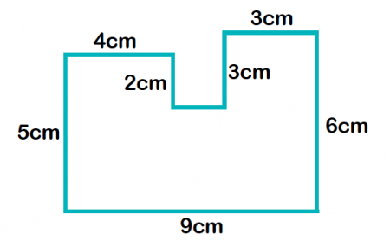

You can work out any unlabelled sides on a shape by looking at the other labelled edges. In this case, the small unlabelled side is 2cm long, since it must be the length of the bottom edge (9cm) minus the two top edges (4cm and 3cm).

To find out the perimeter, you would then need to add up all the sides: 4 + 5 + 9 + 6 + 3 + 3 + 2 + 2 = 34cm.

|  |
| --- |
| Area |

**Area is the term used to define the amount of space taken up by a 2D shape or surface.** We **measure area in square units** :  cm²  or m².

Area is calculated by **multiplying the length of a shape by its width**. In this case, we could work out the area of this rectangle even if it wasn't on squared paper, just by working out 5cm x 5cm = 25cm² (the shape is not drawn to scale).

5cm

|  |  |  |  |  |
| --- | --- | --- | --- | --- |
|  |  |  |  |  |
|  |  |  |  |  |
|  |  |  |  | 5cm |
|  |  |  |  |  |
|  |  |  |  |  |

Finding the area of an irregular shape  
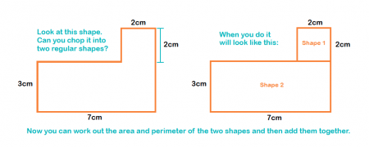

A good way of finding the area of a shape like this is to split the shape up into smaller shapes and then work out the area of each of these. The areas of the smaller shapes can then be added up to find the answer.

2cm x 2cm = 4cm²

7cm x 3cm = 21cm²

Overall area = 4cm² + 21cm²= 25cm²

Finding the area of a parallelogram

To calculate the area of **parallelograms** you multiply the base by the height.

Height 4cm

Base 9cm

If you were to move the triangle formed with the dotted line to join the other triangle you would create a rectangle, so the formula is the same as calculating the area of a rectangle.

Finding the area of a triangle

To calculate the area of **triangles** you multiply the Base by the height and divide by 2.

Height

5cm

Base 5cm

If you were to attach an identical triangle you would form a square, so the formula is the same as calculating the area of a square and halved.

|  |
| --- |
| Angles |

|  |  |  |  |
| --- | --- | --- | --- |
| C:\Users\rdiguilio\Local Settings\Temporary Internet Files\Content.IE5\LIWU9OPJ\Angle_acute[1].png  Acute Angle (less than 90°) | C:\Users\rdiguilio\Local Settings\Temporary Internet Files\Content.IE5\LIWU9OPJ\220px-Right_angle.svg[1].png  Right Angle (90°) | C:\Users\rdiguilio\Local Settings\Temporary Internet Files\Content.IE5\N611Y7WJ\Reflex_angle.svg[1].png  Reflex Angle (more than 180°) | C:\Users\rdiguilio\Local Settings\Temporary Internet Files\Content.IE5\LL3WHCBX\Obtuse_Angle_(PSF)[1].png  Obtuse Angle (over 90° but less than 180°) |

1 right angle = 90° = 1 quarter turn

2 right angles = 180° = half a turn = straight line

3 right angles = 270° = ¾ of a turn

4 right angles = 360° = 1 whole turn

|  |
| --- |
| **Circles** |

The circumference of a circle is its perimeter. The radius goes from the centre of a circle to its circumference.

Circumference

Radius

The diameter goes from one side of a circle to the other through the centre. You can see that the diameter is twice the length of a radius.

Diameter

|  |
| --- |
| **Calculations** |

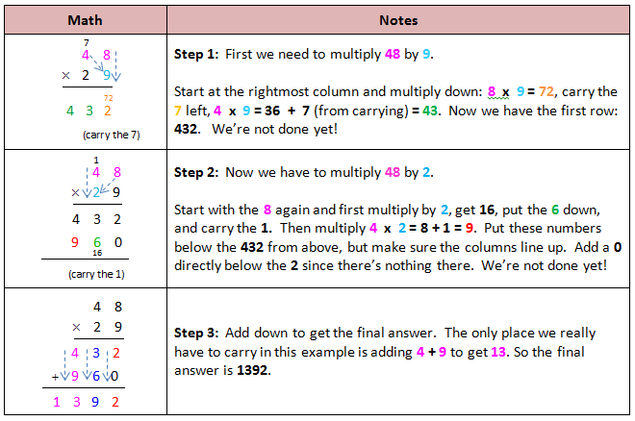**Long Multiplication**

**Note: The zero is known as a place value holder. We are actually multiplying by 20.**

**In order for children to build firm foundations that can be built upon, it is vital that they understand the importance of place value. Teaching your child to simply add a zero or move the decimal point will not achieve this. Your child should instead be taught to recognise a number’s place value and move the number accordingly.**

**Long Division**

Have a look at the calculation: 8,640 ÷ 15

|  |  |
| --- | --- |
| 15 **8** 6 4 0 | 15 can’t go into 8, so look at the next digit. |
| **5**  15 **8 6** 4 0   * **7 5**   **1 1** | 15 goes into 86 five times, so put a 5 above the 6.  **15x5=75**  Take 75 away from the 86 to get your remainder  **86-75=11** |
| **5 7**  15 **8 6** 4 0  **7 5**  **1 1 4**   * **1 0 5**   **9** | Next, carry the 4 down to make 114  15 goes into 114 seven times, so put a 7 above the 4.  **15x5=105** write 105 below 114 and subtract.  Take 105 from the 114 to get your remainder.  **114-105=9** |
| **5 7** **6**  15 **8 6** 4 0  **7 5**  **1 1 4**   * **1 0 5**   **9 0** | Carry the 0 down to make 90  15 goes into 90 exactly 6 times, so put a 6 above the 0.  **15x6=90** write 105 below 114 and subtract.  Take 105 from the 114 to get your remainder.  **114-105=9** |

We teach the following rap to remind them of the process!

‘Divide, multiply then subtract. Bring it on down and bring it on back!’

**Adding fractions with the same denominator**

Ensure you can add fractions with the same denominator before tackling addition with different denominators.

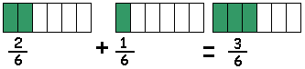

C[onvert the fraction to its simplest form](https://www.helpingwithmath.com/by_subject/fractions/fra_simplifying.htm).

3 is a common denominator.

3 goes into 3 0nce  **1**

3 goes into 6 twice  **2**

**Adding fractions with different denominators**

A common denominator must be found when adding fractions that have different denominators. This is the most important (and probably the hardest) step in adding or subtracting fractions. A common denominator can always be found by multiplying the denominators.

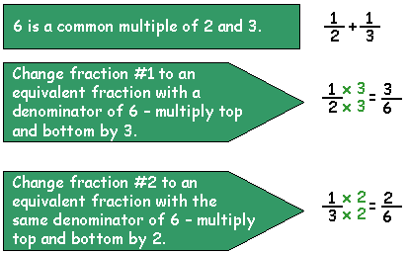

Sometimes the product of the two denominators denominator will not be the *lowest* common denominator. Finding the lowest common denominator in such cases can be a trial and error exercise. Take the highest denominator multiply it be 1, then by 2 ,then by 3 and so on. Each time check to see if the other denominator(s) are also divisors of the number.

**Reducing the answer to its lowest term**

It is good practice to finish by reducing the answer to its simplest form (lowest term) if it is not in that form already.

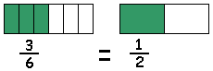

An answer that is not in its simplest form is not necessarily wrong.

**Subtracting Fractions**

Subtracting and adding fractions are very similar. The only difference is the actual subtraction operation. All the steps that come before the operation are the same. However, as with addition and other math operations be sure to show and explore the concept using graphics and, if possible, hands-on exercises.

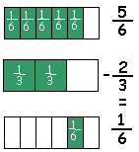

The numeric technique for adding fractions will be better understood once the concept can be properly visualized.

**Subtracting fractions with the same denominator**

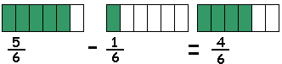

To subtract fractions with the same denominator, subtract the numerator and keep the denominator.

**Subtracting unlike fractions with different denominators**

As with addition, the most important step in subtracting unlike fractions (fractions with different denominators) is finding a common denominator.

A common denominator can always be found by multiplying the denominator although this denominator will not always be the *lowest* common denominator.

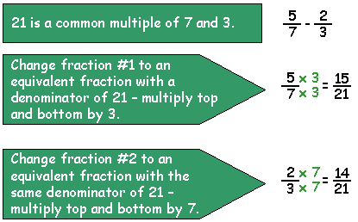

Finding the lowest common denominator can be a trial and error exercise. Take the highest denominator, multiply it be 1, then by 2 ,then by 3 and so on. Each time check to see if the other denominator(s) are also divisors of the number.

**Multiplying Fractions**

Multiplying fractions is relatively straightforward. These are the steps:

* multiply the numerators
* multiply the denominators
* reduce the fraction to its simplest form

These three steps are illustrated below:

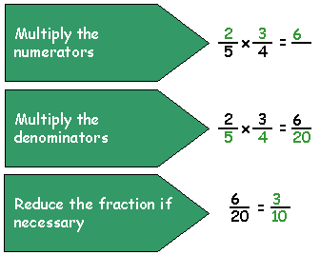

**Common error when multiplying fractions by a whole number**

The example below shows an error that is made by students when the multiplication involves a whole number.

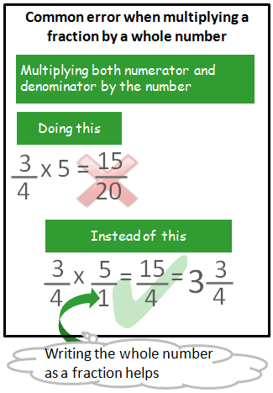

Multiplying the numerator and denominator by the same number is the same as multiplying the fraction by 1.

**How to Divide Fractions**

There is more than one method of dividing fractions. The easiest and most commonly taught way is to “invert and multiply.”

**Dividing fractions – invert and multiply**

To divide fractions take the reciprocal (invert the fraction) of the divisor and multiply the dividend.

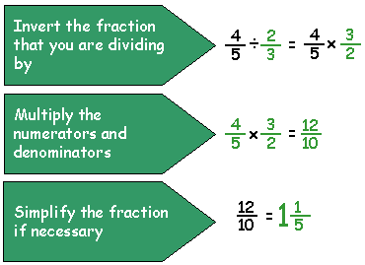

This is the quickest technique for dividing fractions. The top and bottom are being multiplied by the same number and, since that number is the reciprocal of the bottom part, the bottom becomes one. Dividing anything by one leaves the value “anything” the same.

**BODMAS**

**Bracket**

**Order (Squared or Cubed Numbers)**

**Division**

**Multiplication**

**Addition**

**Subtraction**

BODMAS is the order in which we calculate multiple operation sums.

For example: **(40-10) ÷5+1x12=?**

1. **40-10 = 30** **30÷5+1x12=?**
2. **30÷5** **=** **6** **6+1x12=?**
3. **6x12 =72 72+1=?**
4. **72+1=73**

Glossary

A

Acute An angle that when measured is less than 900

Add/ Addition – Plus the two numbers together, e.g 1 + 2 = 3

Algebra – Using letters in the space of unknown numbers.

Angle – The space, measured in degrees, between two lines that meet.

Approximate – To estimate using a number, amount or total.

Arc – A section of the circumference of a circle.

Area – The space inside a shape. This is calculated in different ways depending on the shape

Average – Also known as the mean, the average looks at all the results and add them together. You then divide by the total that there is. This gives an average score overall, taking into account all al the data.

Axis – A set of axes have an *x* axis and a *y* axis.

B

Base – The bottom of something eg/ shape

BODMAS – The order in which you perform the operations. This stands for Brackets, Order, Division, Multiplication, Addition and Subtraction

Brackets - These are included in many maths questions and look like these ( ). You must complete the sum inside the brackets first.

C

Capacity – The amount a container can hold

Centre – The middle

Circumference – The distance around the outside of a circle.

Calculate - Work out

Congruent – This fancy word is used when looking at shapes. It means the same.

Consecutive – Numbers that follow each other in an unbroken sequence

Cube – A symmetrical 3D shape made up of 6 equal squares. An example of this shape is a rubix cube.

Cube number – A cube number is a number times by itself 3 times. Eg/ 1 x 1 x 1 = 1, 2 x 2 x 2 = 8 ….

Cuboid – A 3D shape made up of 6 rectangular faces. An example of this shape is a cereal box.

Cumulative Frequency – A running total of the frequencies.

Cylinder – A shape that has a pair of parallel sides and oval/circular bases. An example of this shape is a Pringles tube.

D

Decimal – Not a whole number eg/ 4.2, 5.690

Degree – A unit used for measuring angles

Denominator – The bottom number of a fraction

Diameter – The line that passes through a circle, from edge to edge, through the centre. It is also twice the radius measurement.

Division – Splitting a number into a smaller one.

Discrete – Discrete is a type of data. It can only take certain values. For example, if you are calculating with people, you cannot have ½ of a person.

E

Equation – Usually seen in Algebra. An equation will always have an equals sign. It is showing that one thing is the same as another.

Equilateral Triangle – A triangle with equal sides and angles.

Estimate – To make an approximation (guess)

Even – This can relate to the even numbers 2, 4, 6, 8 …. Or having an even chance in probabilitiy. This mean you have the same chance as one thing happening than the other.

Expand – Make bigger! An example could be Expand 3(x + 2). This means get rid of the brackets!

Expression – Symbols that represent a number or quantity

Exterior – Outside

F

Factor – A factor are number that can go into other numbers. Eg. The factors of 6 are; 1,2,3,6 because 1 x 6 = 6 and 2 x 3 = 6

Factorise – This is the opposite of expanding. Factorise means putting the brackets back in by looking for common factors.

Fraction – A fraction is part of a whole. The amount which the whole is spilt up into, in down to the denominator. Eg. 1/5 is 1 out of 5 equal parts.

Frequency – Frequency means the total number.

Formula – A rule defined by symbols. Eg/ The formula for the Area of a rectangle = l x w (Length X Width)

G

> - Means greater than or more than

H

Heptagon – A 7 sided shape

Hexagon – A 6 sided shape

Hypotenuse – The longest side on a right angled triangle.

I

Interior – Inside

Isosceles – A triangle that has two equal sides.

L

< - Means Less than.

M

Median – After putting your data in order, the median is the middle value.

Midpoint – In the middle of a line or two points.

Multiple – A number that can be divided by another number without a remainder. The multiples of 5 are 5, 10, 15, 20 etc. (TRICK: It’s the numbers in its times table!)

Mode – The most common data value

N

Numerator – The top number of a Fraction

O

Obtuse – An angle that is greater than 90o but less than 180o.

Opposite Angles – These are equal.

P

Parallel – This is used to describe two lines that will never meet.

Perimeter – The distance area the outside of a shape.

Perpendicular - A straight line at an angle of 90° to another given line. A good example of this is the x and y axis. These 2 lines are Perpendicular to each other.

Polygon – A closed shape with any number of sides.

Pi – An irrational number that is used to calculate the circumference and area of a circle.

Prime – A number that can be divided ONLY by 1 and itself. 1 is not the first prime number!

Prism - A 3D shape with 2 triangular faces. A real life example of a prism is a Toblerone tube.

Probability – The chance of something happening. This can be written as a fraction, decimal or percentage. All probabilities must add up to 1.

Product – The result when two numbers are multiplied together.

Q

Quadrilateral – A word used to describe a 4 sided shape

Qualitative Data – Data categories such as food, sport, hobbies

Quantitative Data – Data that can be counted or measured.

R

Radius – A line inside a circle. It goes from the centre to the edge of the circle, and if half the diameter.

Range – Measures the spread of a data set. This is calculated by taking the lowest number away from the highest number.

Ratio – To split a number/amount/ingredients into parts. Usually in the form n : r which means n to r.

Rational – A real number

Reciprocal – The inverse of a number. One of two numbers whose product is 1 e.g 1/5 and 5, 1/8 and 8

Recurring Decimal – A decimal which has repeating digits

Reflection – A mirror view

Reflex Angle – A reflex angle is greater than 180o.

Revolution – A whole turn (360o)

Right Angle – A right angle is a 90o angle.

Rotation – To turn an object

S

Sample – A selection of a whole group.

Scale Factor – A number expressing how large or small the enlargement of a shape is.

Scalene – A type of Triangle that has 3 unequal sides.

Sector – A part of circle that is made up of 2 radius measurements and a part of the circumference of a circle.

Segment – A part of a circle bound by a chord.

Sequence – An ordered set of number. This follows a particular pattern

Simplify – Make smaller.

Solve – Work out!

Subtraction – Take Away!

Sum – The total when all the parts are added together.

Surface Area – The total area of all the surfaces on a 3D shape.

Square number – A result of a number times by itself.

Square root – A number when multiplied by itself gives the original number

Symmetry – An object is symmetrical when one half is the mirror image of another half.

T

Tangent - A straight line that touches a curve or curved surface at a point. These can be found touching the outer of a circle.

Term - A number in a sequence.

Tessellation – A pattern of shapes that fit together with no gaps.

Trapezium – a 4 sided shape with no parallel sides.

Transformation – To manipulate a shape. In total, there are four transformations. Translation, Rotation, reflection and enlargement

Translation – To move a shape left/right then up/down.

U

Unlikely – Probably won’t happen

V

Variable – A letter than represents a value e.g n + 10

Vertically Opposite Angles – These are angles opposite each other, and are equal in size.

Vertex (Vertices) – Points on a shape

Volume – The space inside a 3D shape. This is measured in cubic units.

W

Width – Distance across from side to side

X

X axis – the horizontal axis on a graph

Y

Y axis – The vertical axis on a graph

Z

Zero – Nothing!