9th July 2025

Dear Parents and Carers,

Update to School Uniform Policy – Footwear Change

As part of the continual exciting implementation of the OPAL (Outdoor Play and Learning) programme, we are making a small but important change to our school uniform policy.

From 4th September 2025, children will be permitted to wear plain black trainers as part of their daily school uniform instead of school shoes. Trainers must be plain black (no colour visible), please see example below.

The OPAL approach encourages children to be more active, creative, and engaged during playtimes, with access to a wider range of outdoor experiences in all weather conditions. As a result, children are likely to be moving more frequently and energetically throughout the day. Trainers will provide the comfort, flexibility, and support needed for safe and active participation in outdoor play.

Please note the following guidelines for acceptable trainers are:
- Plain, black trainers (no flashing lights or bright designs/colours including coloured logo)
- Must be suitable for active play (no slip-ons)

We hope this change will support our children in fully enjoying the opportunities OPAL offers, while maintaining a smart and practical school appearance.

Thank you for your support as we continue to make St Paul’s a place where play and learning thrive together.

If you have any questions, please do not hesitate to contact us.

Kind regards,
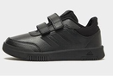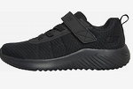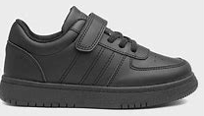
Mrs Worton-Geer
Headteacher

